# **The role of alkalis on the incorporation of iodine in simple borosilicate glasses**

# **Authors: Boris Vénague, Lionel Campayo, Jean-Luc Dussossoy, Michael J. Toplis**

# 

# **Abstract**

The purpose of this study was to identify incorporation mechanisms and saturation levels of iodine in borosilicate glasses that are simplified versions of compositions used for nuclear waste containment. Several series of glasses with different alkali contents (22 or 35 mol% Na2O, or 22 mol% of a mixture of Na2O + Li2O, K2O or Cs2O) were loaded with iodine (from 1 000 to 10 000 ppm at.) at 1100 °C in a specially-designed closed system. When the incorporation limit of iodine was reached, alkali iodide crystals were observed (e.g. NaI, KI…). Crystal-free pools of glass were studied by Electron Probe Micro-Analysis (EPMA) to measure the incorporation limit of iodine, which ranges from 892 ppm at. for a cesium–bearing glass to 7260 ppm at. for the glass with 35 mol% Na2O. The composition of the crystals was analyzed by Inductively Coupled Plasma spectroscopy (ICP) and it was systematically found that crystals are enriched in the heavy alkali compared to the bulk composition. Correlations exist between the saturation level and the composition of the crystals. It is concluded that high alkali content in general and high concentration of Na2O in particular is favorable for iodine incorporation.

# Introduction

In France, the choice has been made to reprocess spent nuclear fuels in order to recycle their U and Pu to produce new fuel assemblies, and to condition the Fission Products (FPs) and minor actinides (i.e. final waste) in a glassy matrix [1]. Currently, the Plutonium and Uranium Refining by Extraction (PUREX) process, which consists of a series of chemical extractions, is used to separate uranium and plutonium from final waste [2]. This waste is conditioned in an aluminoborosilicate glass, called “R7T7” [3]. ANDRA, a French organization in charge of nuclear waste management, is studying the disposal of such High Level Waste (HLW) glasses in a deep geological repository [4]. In this context, it has been found that iodine (I129) would be the principal contributor to potential contamination of the biosphere [5, 6]. This fact is related to the transport properties of iodine in a clay environment in the presence of water. Indeed, iodine present as I- (the oxidation state present in the glass [7, 8]) is readily transferred to a fluid phase at such conditions, leading to migration of I at the same speed as the transport of water [5, 6].

Before treating the question of transport of iodine to the environment over long time spans, it is essential to begin by quantifying the retention of iodine in the initial glass produced by the vitrification of raw waste materials. The concentration of I in these pristine glasses depends on various parameters, in particular the initial iodine concentration in the waste, the losses by volatilization during vitrification, and the formation of iodide salts that can migrate to the top of the melt. Study of the incorporation of iodine in borosilicate glass has focused on the treatment of Low-Level Waste (LLW) from the Hanford site in the U.S.A. [7, 8, 9, 10]. These studies have determined that the dominant valence state of iodine is I-, and that iodine is surrounded by alkali elements [7, 8]. Riley et al. measured an incorporation limit of about 1%wt I in their LLW glass formulation at 1000 °C under conditions that minimize volatilization (sealed quartz tubes) [8]. Moreover, McKeown et al. highlighted a link between the proportion of lithium and sodium in the glass and the retention rate of I [7], possibly related to the local environment around iodine atoms (i.e. the strength of chemical bonds between iodine and sodium or lithium which leads to variations in volatility). Finally, the influence of pressure for simplified silicate, borate and borosilicate glasses was studied by Grousset [11], who concluded that there is only a weak impact on the incorporation limit of I within the pressure range studied (up to 0.2 GPa).

In this study, investigations were carried out in order to determine the influence of composition on the incorporation of iodine for glasses similar to R7T7. As the data available indicate that alkali species are present in the vicinity of iodine and that they play an important role in the incorporation of iodine content in SiO2 and B2O3 – based network glasses, this study focuses on: i) the influence of total alkali content, and ii) the mixed alkali effect at fixed total alkali content.

# Material and methods

## Glass composition

Simplified versions of the glass R7T7 have been studied in order to identify individual compositional effects (Table 1). In detail, starting from R7T7, all minor components were removed or replaced to obtain a glass formulation composed of sodium, aluminum, boron and silicon oxides. A second glass composition, enriched in Na2O, was defined by increasing the alkali content to 35 mol% while keeping the Si/Al and Si/B ratios constant. It should be noted that the latter composition does not truly represent a glass designed for nuclear waste conditioning, due to its high Na2O content. However, it was included to investigate the role of total alkali content.

|  |  |  |  |  |  |  |  |
| --- | --- | --- | --- | --- | --- | --- | --- |
|  |  | **SiO2** | **B2O3** | **Al2O3** | **Na2O** |  | **Total** |
| **(a)** | **Mol %** | 59.02 | 15.27 | 3.69 | **22.02** |  | 100 |
|  | **Wt %** | 55.85 | 16.74 | 5.92 | 21.49 |  | 100 |
|  |  |  |  |  |  |  |  |
| **(b)** | **Mol %** | 49.14 | 12.71 | 3.07 | **35.08** |  | 100 |
|  | **Wt %** | 46.68 | 13.99 | 4.95 | 34.37 |  | 100 |

Table 1: Simplification of R7T7 glass to (a) four-oxide analog (22 %mol Na2O), and (b) high-Na variant (35 %mol Na2O).

The study of the influence of total alkali content was limited to sodium because Na is the main alkali present in the industrial glass. To investigate the role of other alkalis, work focused on the 22 mol% Na2O glass, progressively replacing Na2O by another alkali oxide, while keeping the overall alkali content constant (Figure 1). For the NaK mixture, the complete range from a pure sodium-containing to a pure potassium-containing glass was studied. For mixed-alkali glasses containing lithium or cesium, the maximum substitution was 50 % for lithium, and 25 % for cesium, higher levels of substitution leading to heterogeneity. Indeed, preliminary tests performed on simplified glasses containing 50 % and 100 % cesium contained large quantities of bubbles and showed phase separation between Si-rich areas and B-rich areas, with the crystallization of pollucite (CsAlSi2O6) in the Si-rich areas, as previously observed by Caurant et al. [12] for similar conditions. For the Li-bearing glass, literature data [12, 13, 14] also indicate phase separation, followed by the formation of cristobalite (SiO2) in this case.

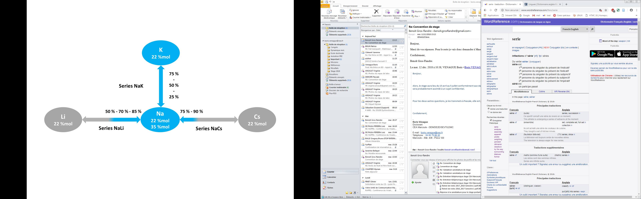

Figure 1: Alkali compositional field– All compositions studied are in blue (the values along the arrows indicate the extent of molar substitution)

## Glass preparation

The glasses were labeled according to their nominal composition: V-AI-x-z (mono-alkali glass) or V-A1A2I-x-y%-z (mixed alkali glass), with A, A1 and A2 the alkalis present in the glass, x the global alkali oxide content (mol%), y the relative percentage of sodium among alkalis (where relevant), and z the initial (nominal) iodine content (ppm at.). For example, the V-NaKI-22-75%-2500 glass contained a total of 22 mol% alkali of which 75 % is Na2O (16.5 %mol) and 25 % K2O (5.5 %mol), with a nominal bulk iodine content of 2500 ppm at.

Iodine volatility is one of the main issues when making iodine rich glasses. In this study, a closed system was used to overcome this problem. In detail, the glass was prepared in two steps. In the first, an iodine-free glass was made, corresponding to the target composition, minus a relevant amount of AI (A: Na or K for Na-free compositions). Each glass of Table 2 thus required a separate synthesis. These I-free glasses were prepared using analytical reagent-grade SiO2, Al2O3, H3BO3, Li2CO3, Na2CO3, K2CO3, and CsNO3 powders.CsNO3 was chosen rather than Cs2CO3 to avoid problems of hydration during weighing. Each batch was heated in a Pt-Au crucible in a muffle furnace from room temperature to 850 °C at a heating rate of 3.2 °C/min, and held for 1 h in order to remove water, nitrate, and carbonate groups. The batch was then heated to 1100 °C at a rate of 2.8 °C/min, and held for 3 h to ensure homogenization. The melt was then quenched by pouring onto a metallic plate in air, the resulting glass being ground with a planetary mill and sieved with a 200 μm square mesh.

In the second step, approximately 12 g of I-free glass powder was mixed with the appropriate amount of iodine in the form of NaI (or KI for potassic compositions). This mixture was placed in a Pt-Au crucible and inserted into an airtight assembly consisting of two alumina crucibles sealed with glass frit (Figure 2). The assembly was inserted into a furnace at 1100 °C to melt the seal before iodine started to volatilize thanks to the thermal gradient. Samples were held at 1100 °C for 3 h, except for the NaK series where 9 h were needed to reach a homogeneous glass. These run durations were chosen thanks to SEM observations of glass homogeneity, as presented below. After heat-treatment at 1100 °C, the assemblies were removed from the furnace and allowed to cool at room temperature for 10 minutes before opening.

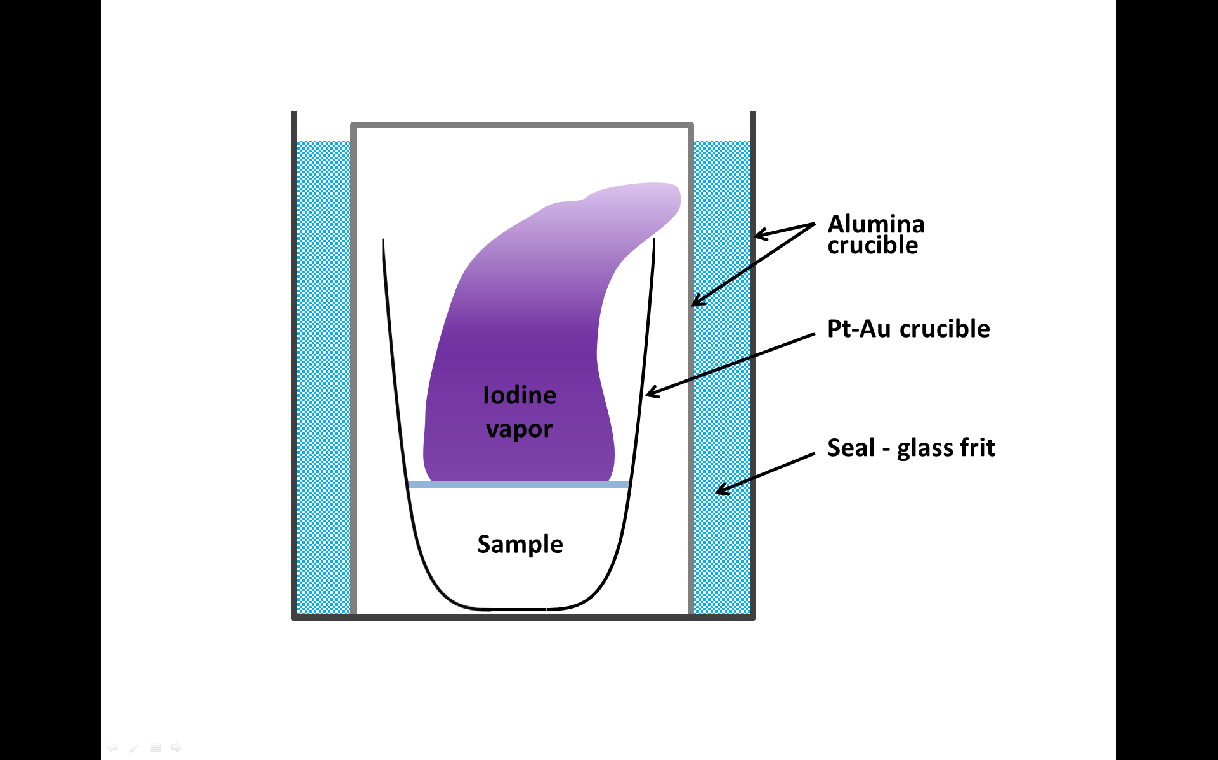

Figure 2: Sealed assembly used for each sample

## Material and analysis method

### Sample preparation

Each sample was cut with an oil-lubricated saw along the main axis of the crucible. The samples were then embedded in epoxy resin before being polished to 1 μm diamond grade with oil solution. No water was used during this preparation to avoid the dissolution of potential iodine-containing crystals. Finally, each sample was carbon coated for SEM observations using a Desk V TSC designed by Denton Vacuum.

### SEM observations

Preliminary analyses of glass composition (to check the degree of homogeneity) were carried out on polished samples using a Scanning Electron Microscope (SEM) equipped with an Energy Dispersive X-ray spectrometer (EDX) for quantitative analyses. The device used was a Zeiss SupraTM 55 SEM, operating at 15 kV with a probe current of 1 nA and equipped with a Bruker AXS X-Flash Detector 4010 system calibrated with crystalline standards.

For each sample, a series of 10 quantitative analyses evenly distributed over the sample were performed. The optimal run duration was assessed by analyzing a low I-content glass for each series (around 1000 ppm at. corresponding to glass n°1 on Figure 3). The duration was considered sufficient whether the standard deviation of EDX measurements was smaller than the uncertainty limits of this technique (0.1 wt% for iodine). Beside this, an approximate estimate of the iodine incorporation limit was obtained in this way by analyzing high I-content glass (corresponding to glass n°3 and n°4 on Figure 3). In addition, it was checked that alkali volatility was within the uncertainty limits of this technique (mean experimental value for alkalis not different by more than 2 wt% from nominal value), especially for the NaK and NaCs series.

### EPMA analysis

High resolution quantitative analyses were performed by Electron Probe Micro-Analysis (EPMA) at the University of Lille (ENSCL - France). A Cameca SX100 equipped with 4 Wavelength Dispersive X-ray Spectrometers (WDS) was used. The analyses were carried out at 15 KeV with a probe current of 15 nA under defocused conditions of 20 μm, to reduce alkali migration under the electron beam. For each sample, 20 measurements were averaged.

As Li cannot be analyzed by EPMA, the Li2O content for the NaLi series was obtained by difference after charge balance correction for oxygen from all other measured elements.

For the following, we consider that iodine in glass occurs only in the form of iodide, compensated by alkalis. The alkalis not associated with iodine are assumed to be associated with oxygen.

### ICP analysis

Inductively Coupled Plasma (ICP) techniques were used to analyze the composition of the iodide crystals (when present) in cooled samples.

To make crystal-rich samples, bulk compositions with I concentrations ~2000 ppm at. higher than the saturation limit of the composition of interest were prepared, using the protocol presented earlier. Once cooled to room temperature, pure water was poured into the Pt-Au crucible to dissolve the iodide-containing crystals. The concentration of iodide and alkali in the solution was estimated by weighing the sample before and after leaching of the crystallization. Part of the solution obtained was acidified with 1.5 N HNO3 for the analysis of Li, Na, K, Cs, and B, and the rest underwent I analysis without further preparation. This precaution was taken to prevent the volatilization of iodine under acid conditions.

The samples were then analyzed at the FILAB Laboratory (Dijon, France) after suitable dilution (parameters used are summarized in table 4). Finally, Li, Na, K, and B were analyzed by Inductively Coupled Plasma Atomic Emission Spectroscopy (ICP-AES), whereas I and Cs were analyzed by Inductively Coupled Plasma Mass Spectroscopy (ICP-MS).

## Determination of the incorporation limit

The variation of iodine concentration of glass after equilibration as a function of nominal addition of I can typically be divided into two parts (Figure 3). At low iodine concentrations, the nominal and incorporated concentrations are close, until the saturation limit is reached. Above this point, samples were found to contain small iodine-bearing crystals (typically 100 to 500 nm in size). These crystals tended to migrate to the top or the bottom of the crucible as soon as there were enough of them. In terms of glass composition, the iodine content of the glassy fraction is approximately constant, consistent with expectations, higher bulk iodine content leading to more crystals formed.

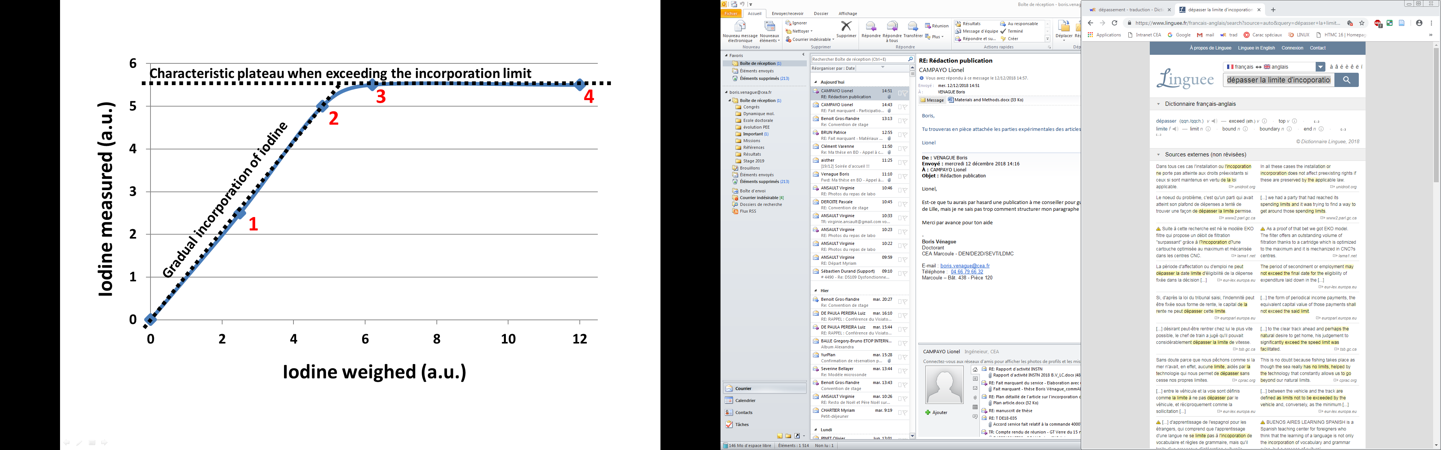

Figure 3: Characteristic evolution of the incorporation of iodine in a borosilicate glass with the typical position of each fabricated glass numbered in red (lines are only given as guides)

For each series, the first sample, of low iodine content (labeled 1 in Figure 3), was made to check that a homogeneous sample could be obtained using the methodology presented above, on the basis of SEM characterization. Then, a second glass, of high bulk iodine content (labeled 4 in Figure 3), was produced to assess the solubility limit of iodine in the glass. The next step was the production of glasses 2 and 3 with bulk iodine contents bracketing the estimated saturation limit.

Finally, each glass was analyzed by EPMA and the incorporation limit was precisely determined by averaging the iodine content of glasses n° 3 and n° 4 (i.e. those known to be saturated in iodine). Large crystal-free areas for glass analysis (greater than the size of the defocussed beam) were typically easy to find, as crystals generally migrate to the surface or the bottom of the sample. This was the case for all samples except that of the pure K-bearing composition, which had the highest viscosity of the glasses studied here. In this case, crystals were present throughout the sample and special care was taken in the choice of areas to be analyzed.

# Results

## Glass compositions and first observations

For each series of experiments, 4 glasses were made and approximately all added iodine was retained in the glass before reaching the saturation limit (EPMA results not shown in Table 2). This excellent correlation confirms the airtight nature of the crucible assembly and the reliability of the setup. Above the saturation limit, crystals were observed for each compositional series. The composition of each glass used for the determination of the saturation limit of iodine is presented in Table 2.



Table 2: Nominal and analyzed composition of each glass used for the determination of the incorporation limit of iodine - EPMA analyses and a post-treatment (for more details refer to the text) – average standard deviation per element (%mol): SiO2 = 0.44 ; B2O3 = 0.46 ; Al2O3 = 0.05 ; Li2O = 1.72 ; Na2O = 0.36 ; K2O = 0.14 ; Cs2O = 0.10 ; NaI = 0.03 ; KI = 0.03

## Influence of the alkali content in pure Na-containing glass

The iodine content of the final glass presented as a function of total added iodine is shown in Figure 4. This figure shows that the incorporation limit of I is higher at higher alkali content. In detail, when the sodium oxide content increased from 22 to 35 mol%, the incorporation limit of iodine went from 3046 to 7260 ppm at. I, an increase of 138 %.

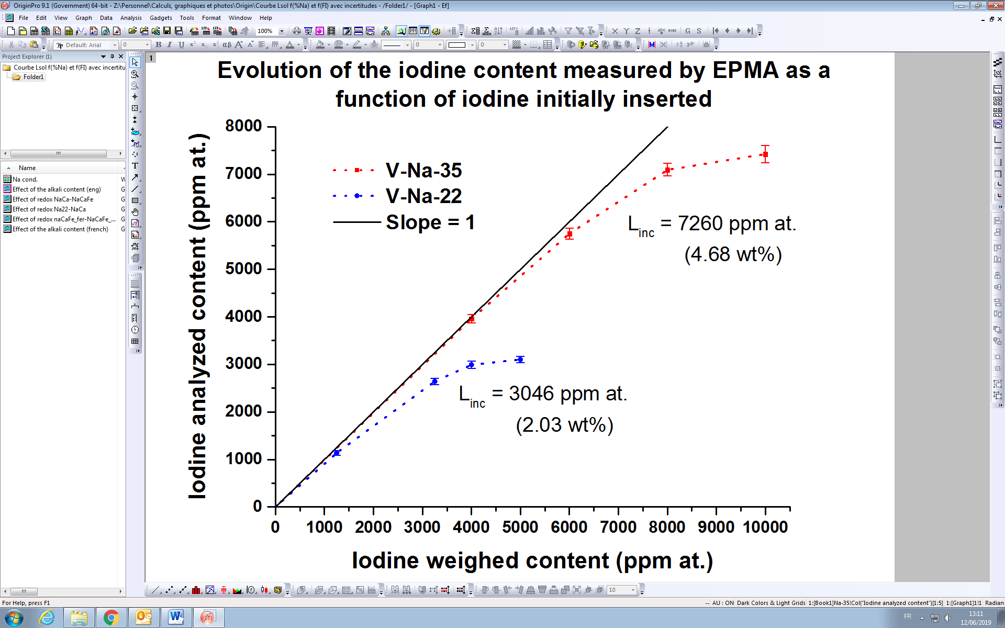

Figure 4: Evolution of the iodine content measured by EPMA as a function of iodine initially inserted in a sodo-aluminoborosilicate glass for different alkali contents (red: 35 %mol – Blue: 22 %mol) – *error bars represent the standard deviation of 20 measurements -* (lines are guides only )

## Influence of the nature of the alkali in aluminoborosilicate glass

For a given alkali content of 22 mol%, our results show a significant influence of the nature of alkalis present (Figure 5). For example, the substitution of sodium by lithium leads to a modest decrease in the solubility limit of iodine. On the other hand, the substitution of sodium by potassium leads to a considerable decrease of this limit, although this trend is not linear, a characteristic that was difficult to quantify for the NaLi series. In detail, for the NaK series, the decrease in solubility limit is strongest for small additions of K, flattening off when half of the sodium content is replaced, before increasing again when the glass contains only potassium. Finally, the substitution of sodium by cesium leads to an even more drastic decrease in the solubility limit of iodine, substitution of only a quarter of the sodium by cesium leading to a decrease of 71 % in iodine concentration at saturation. As observed for potassium, the decrease in solubility is more pronounced for small substitutions of cesium. For further comparison, incorporation limits expressed in ppm at. and wt% are listed in table 3.

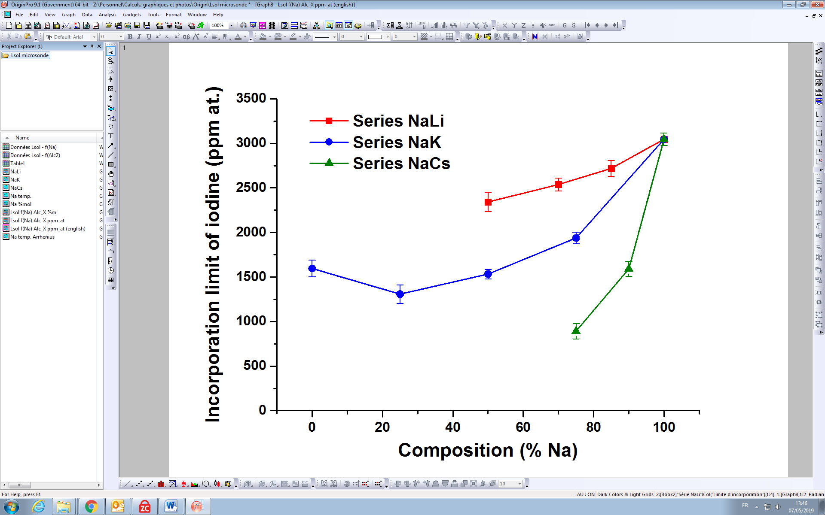

Figure 5: Evolution of the incorporation limit of iodine measured by EPMA in simplified aluminoborosilicate glasses for different alkali substitutions (red - NaLi series; Blue - NaK series; Green - NaCs series) – error bars represent the average standard deviation of two samples used to determine each incorporation limit - (lines are guides only)



Table 3: Incorporation limits of iodine for each composition expressed in ppm at. and ppm mass. – Std Dev. represents the average standard deviation of two samples used to determine each incorporation limit

## crystal compositions

All the data collected on crystals are summarized in Table 4. For each glass, the order of magnitude of the sum of elemental concentrations was consistent with the expected concentration (deduced from weighing before and after exposure of the glass to water). The main source of deviation was linked to I and Cs, as the analysis accuracy was limited by the dilution factor (1/1 000 000). The concentration of boron in the dissolved material was very low, but some was present, probably due to the deposition of borate vapor inside the Pt-Au crucible during the cooling of the assembly. Concerning the iodine content, values of iodine concentration (relative to those of alkalis) are found to be consistent with the assumption that all measured I was in the form of charge balanced I- cations.

In detail, these analyses show that the composition of the crystals is a sensitive function of the composition of the melt. In particular, the analyses highlight a larger proportion of the heavier alkali in the crystals compared to the bulk alkali ratio of the composition in question (Figure 6). For example, the crystals collected on the NaLi-22-50% glass contained almost only sodium (98 % compared to the bulk value of 50 %). In the NaK-22-50% glass there is 21~% of sodium in the crystals, compared to 50 % in the bulk. Finally, for the NaCs-22-75% glass, the crystals contained only 24 % of sodium compared to 75 % in the bulk. Crystalline iodides are thus clearly enriched in heavier alkalis compared to the bulk system.

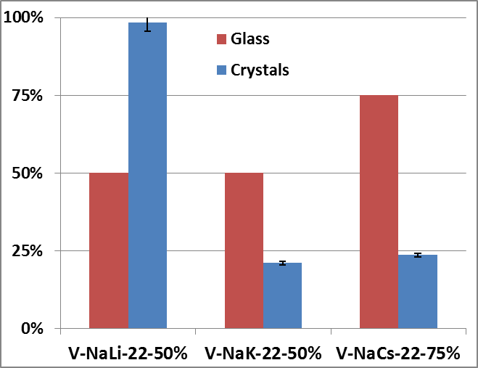

Figure 6: Evolution of the sodium content in the glass (red) versus sodium content in the crystals (blue) expressed in percent of the total alkali content (%mol). Calculations based on the nominal composition for the glass and on data collected by ICP for the crystals



Table 4: Data collected by ICP analyses of the crystals collected after cooling of a high-iodine glass . The precision levels indicated are based on the element analyzed, its content and the analysis conditions. dilution factor not taken into account.

# Discussion

## Influence of the total alkali content in pure Na-containing glass

As shown in figure 4, there is a strong increase in the saturation limit of iodine with increasing Na content. This behavior is consistent with the evolution of iodine retention measured by McKeown et al. with increasing Na2O + Li2O (mol%) content in aluminoborosilicate glasses [7]. On the other hand, despite similar total alkali contents [8], the incorporation limit for V-NaI-22 (~3000 ppm at.) is higher than that measured by Riley et al. (1641 ppm at.) at 1000 °C for an aluminoborosilicate glass designed for the conditioning of LL waste [8]. In the study of Riley et al., the glass was also synthesized in a confined atmosphere, but it was more complex (13 oxides instead of 4). Of particular note is the fact that many elements in that glass require charge compensation (e.g. B2O3, ZrO2, Fe2O3). For this reason, the amount of ‘free’ alkali oxide (i.e. that not in charge-balancing roles) is lower than in the simplified glass investigated here. In addition, this difference is probably also related to the variation of the refining temperature as an increasing saturation limit is expected with increasing temperature [26].

To explain the dependence of the level of iodine saturation on sodium concentration, two principal explanations can be proposed. First of all, this behavior could be related to a chemical affinity between iodine and sodium, higher concentrations of sodium directly increasing the solubility of I. Alternatively, the saturation limit of iodine could be controlled by physical parameters (steric hindrance), the observed correlation being an indirect effect of sodium oxide on the structure of the glass network.

To test the first hypothesis, we have used the modified Dell & Bray model introduced by Du and Stebbins [15]. This model allows us to estimate the proportion of four-fold boron, named N4, and the proportion of Non-Bridging Oxygen (NBO) in our glasses, the influence of the presence of iodine on the latter being ignored given its low concentration. For V-NaI-22, N4 is expected to be about 62 % and the proportion of NBO is estimated to be 9 % (Table 5). For V-NaI-35, N4 is expected to be about 42 % and the proportion of NBO is estimated to be 27 %. There is thus a huge increase in the number of NBO when sodium oxide concentration increases from 22 to 35 mol%. Qualitatively, larger Na-rich depolymerized areas are expected in the V-NaI-35 glass that could be favorable for I incorporation [16]. Quantitatively, the order of magnitude of the evolution of NBO (+ 200 %) is similar to that of the solubility limit (+ 138 %), supporting the hypothesis of a direct link between the concentration of NBO and I-solubility.



Table 5: Estimation of the glass structure calculated using the modified Dell & Bray model - Calculations are based on the nominal composition of the undoped glass and all aluminum is assumed to be in four-fold coordination [15]

To address the second hypothesis of a physical control on I solubility, we compare the evolution of the solubility limit of iodine with that of noble gases, the latter having no chemical interactions with elements of the glass network. Noble gas solubility has been found to vary as a function of ionic porosity, a measure of the “free space” in the glassy network structure [17]. In general terms, with increasing ionic porosity, the solubility of noble gases increases. Larger atoms have lower solubility and are more sensitive to ionic porosity, as illustrated in Fig. 7. Equivalent data for our glasses are presented in Table 6. I and Xe have comparable radii (220 pm for I- [28] and 216 pm for Xe [29]), but comparison of their solubilities shows that the solubility limit of I is orders of magnitude above that predicted for Xe. Furthermore, the observed increase in the incorporation limit of iodine (expressed as ln Xi, with Xi the molar fraction of iodine per bar) from -6.2 (in V-Na-22) to -5.3 (in V-Na-35) is anti-correlated with ionic porosity, in contrast to the case of Xe. These observations clearly indicate that the solubility mechanism of I differs from that of Xe, consistent with the idea of a dominant role of chemical interaction with glass-forming elements, in particular, alkali elements.



Table 6: Ionic porosity (%) and ln(Xi), with Xi the molar fraction of iodine per bar, calculated for the glasses studied. IP = 100 * (1 –Vca* D) with Vca the volume occupied by cations and anions and D the density estimated at 1100 °C temperature. The calculations of Vca were based on the methodology given by Carroll et al. [17] 1 The estimations of the density at 1100 °C are based on the evolution of density as function of temperature of the glass R7T7 [18] 2 Knowing that the proportion of iodine volatilized can be neglected (the retention is close to 1), the pressure was calculated as a function of the natural increase of pressure with temperature

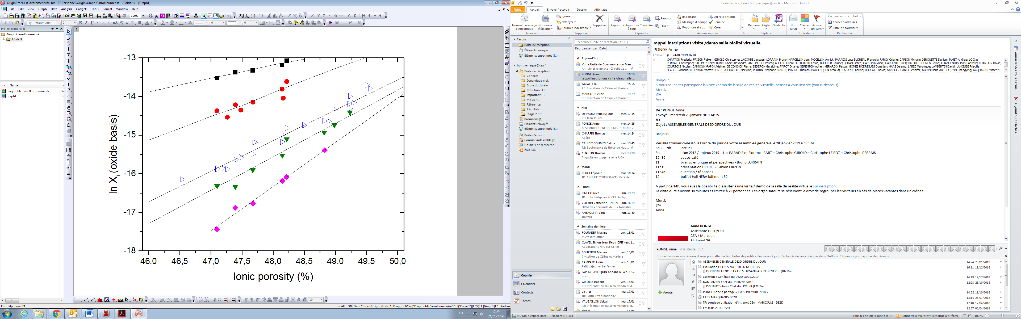

He

Ne

Ar

Kr

Xe

Figure 7: Noble gas solubilities (expressed as mole fraction bar-1) as a function of ionic porosity in melts ranging from 40 to 100 wt% SiO2 at 1000-1400 °C ; data sources and calculation methods are described by Carroll et al. [17]

## II. Influence of the nature of the alkali in aluminoborosilicate glass

As illustrated above (Figure 5), the nature and mixture of the alkali(s) have an important influence on the solubility limit of iodine. The solubility limit is highest when the glass is composed of Na oxide or a mix of Na and Li oxide. This observation is coherent with literature data. For example, McKeown et al. measured the retention of iodine in different compositions of borosilicate glasses [7]. In terms of alkali content, those glasses contained mainly sodium and a variable proportion of lithium or potassium. By comparing each glass, they found a correlation between the Na2O + Li2O (%mol) content and the retention of iodine, and concluded that potassium was less favorable than sodium and lithium for stabilizing iodine in the glass. The trend highlighted in their study is thus consistent with the results from Figure 5.

Concerning a wider range of alkalis, the data presented here highlight the complex nature of variations of iodine solubility limit as a function of the nature of alkalis present, even at constant total alkali content. These variations of solubility limit include the three following characteristics: i) the solubility limit of a pure K-bearing melt is lower than that of a pure Na-bearing melt; ii) upon substitution of small amounts of other alkalis for Na, solubility decreases in all cases, most drastically for Cs and least for Li; iii) for the NaK series that is complete, the variation of solubility limit is non-linear and passes through a minimum.

To explain these variations, we assess the role of alkalis on melt structure with the aim of identifying mechanisms that can result in the observed behavior of I-solubility. We assume in all cases that iodine is preferentially incorporated in depolymerized areas of the glassy network that are rich in NBO.

i) An effect of alkali on the number of NBO

In light of the fact that total NBO content has a significant role on I-solubility (Fig. 4), we begin by exploring the possibility that an NBO effect is at work, even at constant alkali content. This is possible given that species such as [4]B or [5]Al may be in variable proportions, leading to more or less alkalis available for the creation of NBO. In detail, high field strength alkalis decrease the proportion of four-fold boron [19] and increase the proportion of five-fold aluminum, though this second effect can be neglected in our range of composition because the aluminum content is very low [21]. In other words, substitution of heavy alkalis will tend to increase the proportion of four-fold boron and, thus, decrease the NBO content of the melt. However, the number of NBO that will be eliminated by this mechanism remains modest [23, 27] and it is not sufficient to explain the magnitude of I-solubility decrease for K and Cs substitution, nor the fact that solubility *decreases* for Li substitution (solubility should *increase* if an NBO effect dominates).

An interesting corollary of this exercise concerns the distribution of alkalis between different structural roles (e.g. associated with NBO or in charge balancing roles). Bond-strength arguments and direct study using NMR indicate that four-fold boron and aluminum atoms have a preference to be charge balanced by heavier alkalis (e.g. [22]). In this case, Cs should preferentially stabilize Al and B in four-fold coordination compared to other alkalis. In the extreme case of 100 % efficiency to charge balance, from a stoichiometric point of view, all Cs could be in a charge-balancing role in our glasses. This idea contrasts with the fact that CsI crystals are observed above the saturation limit of I, indicating that network-modifying Cs was indeed present. However, we note that there is not an inconsistency here, because even in the least favorable case of the NaCs-90 % glasses, less than 5 % of the total Cs of the bulk composition is associated with iodine. In other words, our data are consistent with a strong preference of Cs for charge-balancing roles, but that the degree of this preference is not 100 %, leading to a population of heavy alkalis (including Cs) associated with NBO.

ii) The role of bond strength between alkali and iodine.

We recall the observation that iodide crystals are systematically enriched in the heavier alkali relative to the bulk composition (Table 4 and Figure 6), exemplified by the NaLi-22-50% glass, which contained 50 % lithium but less than 2 % lithium in the crystals. Assuming that crystals are representative of the iodine environment in the glass in terms of alkali distribution, this observation indicates that when iodine has the choice between two different alkalis, it will preferentially associate with the heavier of the two. Furthermore, given that heavier alkalis preferentially charge balance Al and B in four-fold coordination (see above), the NBO-rich regions where iodine is incorporated will be locally enriched in *lighter* alkalis relative to bulk composition. This consideration reinforces the conclusion that bond strengths decrease strongly in the order Cs-I > K-I > Na-I > Li-I, an order consistent with standard state heats of formation [30].

On the other hand, it should be appreciated that the relative strength of alkali-iodide bonds is not necessarily directly related to solubility limit. The important parameter is the activity coefficient of I in the borosilicate melt at saturation, that will in turn be a function of the details of melt structure. In this respect we note that at the temperature of equilibration of our experiments (1100 °C), all alkali iodides are molten, implying that the solubility of iodine measured here is limited by saturation of an immiscible I-rich liquid, which crystallizes upon quench. In the following we will explore how borosilicate melt structure can affect saturation in an alkali-iodide melt.

iii) The role of alkalis on melt structure.

In qualitative terms, we identify NBO-rich regions of the melt as the key to understanding iodine saturation. If these regions are more extensive (as is the case for melts richer in NBO), then more iodine can be incorporated. Even at constant NBO content, the size of NBO-regions can be variable, depending on the tendency of NBO to group or to be randomly distributed between cations borosilicate network. In this respect, we note that different alkalis have a significant effect on this tendency for NBO to group together. Whether seen from the point of view of phase separation at high silica content (where a more or less pure SiO2 liquid coexists with a liquid containing all the NBO) [13, 24], or in terms of the dismutation reaction SiO2 + A2SiO3 ⬄ 2 ASiO2,5 (Q4 + Q2 ⬄ 2 Q3 in NMR terminology), in both cases it is lighter alkalis that lead to a greater tendency for NBO to group together [23, 27]. In other words, for Li-bearing melts, NBO-rich regions will be less numerous but more extensive, while for Cs-bearing melts such regions will be much smaller (Fig. 8). This trend provides a simple explanation for the lower solubility of I observed in K-bearing melt compared to Na-bearing and for the decreasing effect on I-solubility going from Cs to K to Li (Fig. 5). In this case, the solubility of a pure Li-bearing would thus be expected to higher than that of the Na-bearing melt. If true, this would imply a non-linear variation of solubility that passes through a minimum, consistent with observations in the NaK series.

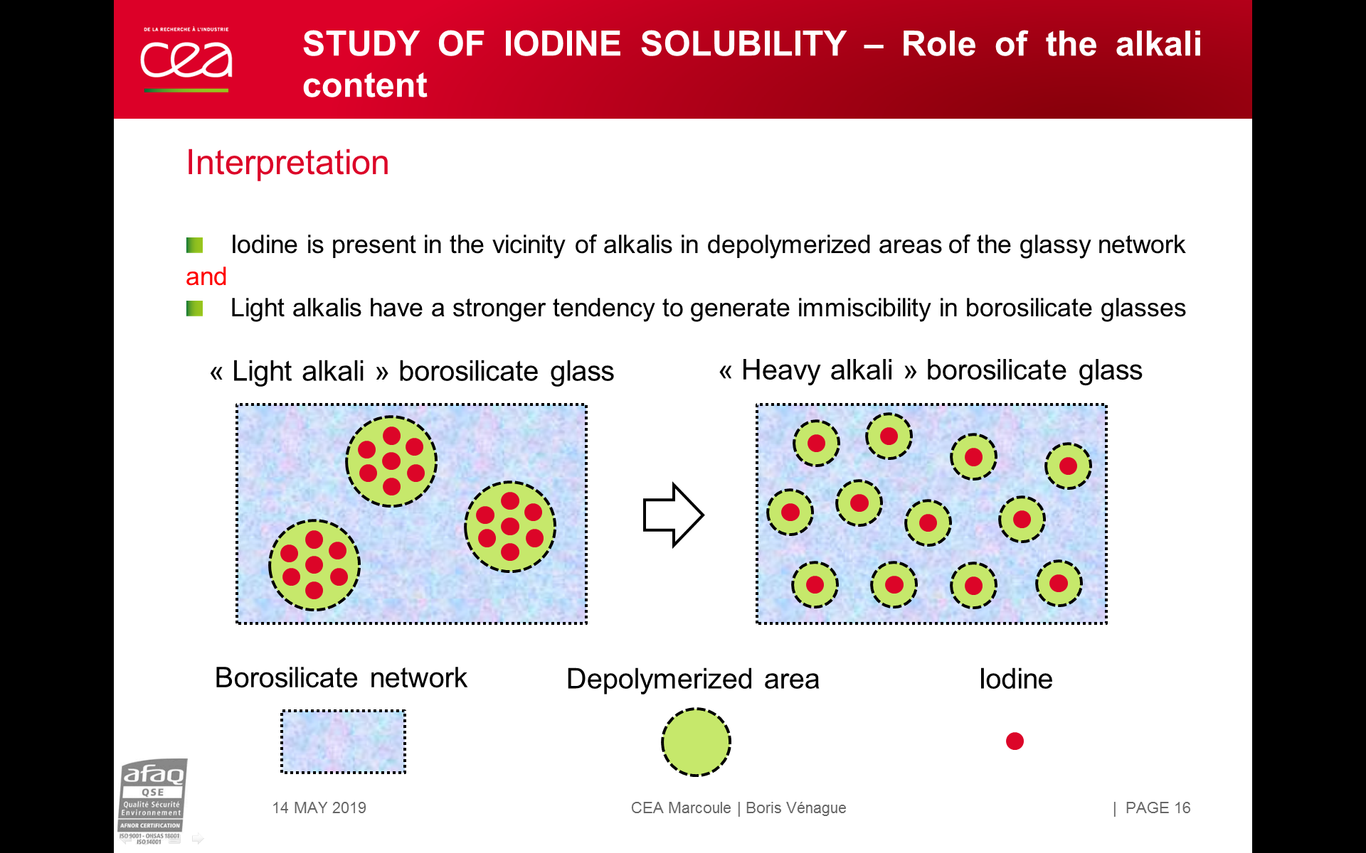

Figure 8: Schematic representation of iodine inside depolymerized areas of borosilicate glasses depending on alkali nature

iv) Origin of non-linearities in the solubility limit as a function of alkali substitution

As illustrated above, the solubility limit of I passes through a minimum going from pure Na-bearing to pure K-bearing compositions, a behavior probable for the NaLi series, and potentially the NaCs series too. In detail, at first glance the minimum in solubility along the NaK join is at 75 % substitution, but if one considers the offset from a linear trend between pure endmembers, the greatest offset from the linear trend is found at 50 % substitution. A maximum offset at 50 % substitution is reminiscent of the well-known mixed alkali effect that creates non-linear variations of properties such as shear viscosity or electrical conductivity [25]. While the details of the mixed alkali effect are not all understood, the entropy of mixing between alkalis, that passes through a maximum at 50 % substitution, is clearly of critical importance.

Using this idea, we propose the following model to take account of all the principal observations concerning the variation of I-solubility. The model is based on the idea that I-solubility is limited by saturation in an immiscible alkali-I liquid. From a thermodynamic point of view the concentration of I in the borosilicate matrix in equilibrium with the immiscible I-rich liquid (i.e. the solubility limit) will be a function of two competing factors. On the one hand, there is the enthalpy of mixing between the iodine and borosilicate liquids that is a repulsive term that favors phase separation and acts to decrease the solubility limit of I in the borosilicate. The fact that NBO-rich regions are smaller in liquids containing heavier alkalis will lead to a greater enthalpy of mixing (i.e. a greater energy penalty to incorporate I), leading to a lower solubility limit, as observed. On the other hand, there is the contribution of the entropy of mixing between borosilicate and alkali-iodide components that acts to stabilize intermediate compositions (thus acting to increase the solubility limit). In the systems studied here, the relative entropy contribution of mixing of borosilicate and alkali-iodide components is greatest for melts containing a single alkali (because entropies of mixing are dominated by mixing between borosilicate and iodide). On the contrary, for liquids containing several alkalis, the entropy contribution of mixing borosilicate and iodide is ‘diluted’ by the fact that each endmember has an entropy contribution of alkali mixing. This ‘dilution’ will be greatest at 50 % substitution of alkalis, where the absolute values of entropy of mixing are greatest (and thus the relative contribution of borosilicate and iodide mixing the smallest). This simple model based upon thermodynamic expectations can thus account for both the variation of solubility limit of I between liquids containing different alkalis, but also explain why the intermediate variations are non-linear, passing through a maximum offset from a linear variation at approximately 50 % substitution.

# Conclusion

This work leads to the conclusion that strong chemical interactions exist between iodine and alkalis in a simplified R7T7 glass. This chemical interaction is used to explain the much higher solubility limit for iodine than xenon, the latter being the closest noble gas in terms of size and whose solubility is only driven by ionic porosity (i.e. lack of any chemical interaction with the glass network).

The solubility limit of iodine was experimentally determined for a simplified aluminoborosilicate version of the R7T7 waste containment glass (Linc (V-Na-22) = 3046 ppm at.) and for a sodium-enriched analog (Linc (V-Na-35) = 7260 ppm at.). The significant increase in the solubility of iodine at higher sodium content is interpreted to be the result of direct interaction between “free” sodium (i.e. that not required to charge balance cations such as B3+ and Al3+) and iodine.

Replacing sodium by other alkalis (Li, K, Cs) was found to lead to a decrease in the solubility limit in all cases. In detail, only the NaK series spanned both pure endmembers, but in general variations of solubility limit include the three following characteristics: i) the solubility limit of a pure K-bearing melt (Linc (V-K-22) = 1596 ppm at.) is lower that that of a pure Na-bearing melt (Linc (V-Na-22) = 3046 ppm at.); ii) upon substitution of small amounts of other alkalis for Na, solubility decreases in all cases, most drastically for Cs (Linc (V-NaCs-22-75%) = 892 ppm at.) and least for Li (Linc (V-NaLi-22-50%) = 2343 ppm at.); iii) for the NaK series, the variation of solubility limit is non-linear and passes through a minimum. In addition, crystalline iodides were found to highly enriched in heavy alkali compared to the bulk composition. All of these observations can be rationalized by a conceptual model based on the idea that I-solubility is limited by saturation in an immiscible alkali-I liquid. In this case, the greater enthalpy of mixing between borosilicate and iodide liquids (that can be related to the size of NBO-rich regions) acts to decrease the solubility limit of I for liquids containing heavy alkalis. On the other hand, consideration of the contribution of entropies of mixing can be used to explain why the intermediate variations are non-linear, passing through a maximum offset from a linear variation at approximately 50 % substitution.

# Acknowledgements

We thank ORANO and EDF for their financial support and their involvement in this project. We are also grateful to Séverine Bellayer, who carried out the EPMA analyses, for her efficiency and her implication.

# References

1. Gin, S., Jollivet, P., Tribet, M., Peuget, S., Schuller, S., 2017. Radionuclide containment in nuclear glasses: an overview. Radiochimica Acta 105. <https://doi.org/10.1515/ract-2016-2658>
2. Herbst, R.S., Baron, P., Nilsson, M., 2011. Standard and advanced separation: PUREX processes for nuclear fuel reprocessing. <https://doi.org/10.1533/9780857092274.2.141>
3. Frugier, P., Martin, C., Ribet, I., Advocat, T., Gin, S., 2005. The effect of composition on the leaching of three nuclear waste glasses: R7T7, AVM and VRZ. Journal of Nuclear Materials 346, 194–207. <https://doi.org/10.1016/j.jnucmat.2005.06.023>
4. Labalette, T., Harman, A., Dupuis, M.-C., 2012. The Cigéo industrial geological repository project. RGN 36–41. <https://doi.org/10.1051/rgn/20125036>
5. ANDRA, 2005. 2005 dossier. ANDRA’s research into the geological disposal of high-level and long-lived radioactive wastes. Results and perspectives.
6. ANDRA, 2005. Dossier Argile 2005 - Tome Evaluation de sûreté du stockage géologique. ANDRA.
7. McKeown, D.A., Muller, I.S., Pegg, I.L., 2015. Iodine valence and local environments in borosilicate waste glasses using X-ray absorption spectroscopy. Journal of Nuclear Materials 456, 182–191. <https://doi.org/10.1016/j.jnucmat.2014.09.033>
8. Riley, B.J., Schweiger, M.J., Kim, D.-S., Lukens Jr., W.W., Williams, B.D., Iovin, C., Rodriguez, C.P., Overman, N.R., Bowden, M.E., Dixon, D.R., Crum, J.V., McCloy, J.S., Kruger, A.A., 2014. Iodine solubility in a low-activity waste borosilicate glass at 1000 °C. Journal of Nuclear Materials 452, 178–188. <https://doi.org/10.1016/j.jnucmat.2014.04.027>
9. Whyatt, G.A., Shade, J.W., Stegen, G.E., 1996. Volatility and entrainment of feed components and product glass characteristics during pilot-scale vitrification of simulated Hanford site low-level waste. Westinghouse Hanford Company, Seattle, Washington.
10. Hrma, P., 2010. Retention of halogens in waste glass. Pacific Northwest National Laboratory, Richland, WA (United States).
11. Grousset, L., 2016. Incorporation de l’iode dans les silicates fondus. Institut de Physique du Globe de Paris, PhD Thesis.
12. Caurant, D. (Ed.), 2009. Glasses, glass-ceramics and ceramics for immobilization of highly radioactive nuclear wastes. Nova Science Publishers, New York.
13. Hattori, Y., Wakasugi, T., Shiomi, H., Nishii, J., Kadono, K., 2012. Li+ for Na+ ion-exchange-induced phase separation in borosilicate glass. Journal of Materials Research 27, 999–1005. <https://doi.org/10.1557/jmr.2012.33>
14. V. McGahay, M. Tomozawa, 1989. The origin of phase separation in silicate melts and glasses. Journal of Non-Crystalline Solids 109, 27–34. <https://doi.org/10.1016/0022-3093(89)90437-7>
15. Du, L.-S., Stebbins, J.F., 2005. Network connectivity in aluminoborosilicate glasses: A high-resolution 11B, 27Al and 17O NMR study. Journal of Non-Crystalline Solids 351, 3508–3520. <https://doi.org/10.1016/j.jnoncrysol.2005.08.033>
16. Frischat, G.H., Poggemann, J.-F., Heide, G., 2004. Nanostructure and atomic structure of glass seen by atomic force microscopy. Journal of Non-Crystalline Solids, Physics of Non-Crystalline Solids 10 345–346, 197–202. <https://doi.org/10.1016/j.jnoncrysol.2004.08.022>
17. Carroll, M.R., Stolper, E.M., 1993. Noble gas solubilities in silicate melts and glasses: New experimental results for argon and the relationship between solubility and ionic porosity. Geochimica et Cosmochimica Acta 57, 5039–5051. <https://doi.org/10.1016/0016-7037(93)90606-W>
18. Linard, Y., Nonnet, H., Advocat, T., 2008. Physicochemical model for predicting molten glass density. Journal of Non-Crystalline Solids 354, 4917–4926. <https://doi.org/10.1016/j.jnoncrysol.2008.07.013>
19. Yamashita, H., Inoue, K., Nakajin, T., Inoue, H., Maekawa, T., 2003. Nuclear magnetic resonance studies of 0.139MO (or M′2O) · 0.673SiO2 · (0.188−x)Al2O3 · xB2O3 (M=Mg, Ca, Sr and Ba, M′=Na and K) glasses. Journal of Non-Crystalline Solids 331, 128–136. <https://doi.org/10.1016/j.jnoncrysol.2003.08.086>
20. Wu, J., Stebbins, J.F., 2013. Temperature and modifier cation field strength effects on aluminoborosilicate glass network structure. Journal of Non-Crystalline Solids 362, 73–81. <https://doi.org/10.1016/j.jnoncrysol.2012.11.005>
21. Wu, J., Stebbins, J.F., 2009. Effects of cation field strength on the structure of aluminoborosilicate glasses: High-resolution 11B, 27Al and 23Na MAS NMR. Journal of Non-Crystalline Solids 355, 556–562. <https://doi.org/10.1016/j.jnoncrysol.2009.01.025>
22. Du, L.-S., Stebbins, J.F., 2003. Site Preference and Si/B Mixing in Mixed-Alkali Borosilicate Glasses: A High-Resolution 11 B and 17 O NMR Study. Chemistry of Materials 15, 3913–3921. <https://doi.org/10.1021/cm034427r>
23. Du, L.-S., Stebbins, J.F., 2003. Solid-state NMR study of metastable immiscibility in alkali borosilicate glasses. Journal of Non-Crystalline Solids 315, 239–255. <https://doi.org/10.1016/S0022-3093(02)01604-6>
24. F.Y. Galakhov, V.I. Averjanov, V.T. Vavilonova, M.P. Areshev, Fiz. Khim. Stekla 7 (1981) 38.
25. Isard, J.O., 1969. The mixed alkali effect in glass. Journal of Non-Crystalline Solids 1, 235–261. <https://doi.org/10.1016/0022-3093(69)90003-9>
26. Crichton, S.N., Barbieri, T.J., Tomozawa, M., 1995. Solubility Limits for Troublesome Components in a Simulated Low Level Nuclear Waste Glass. Ceram. Trans. 61, 283–290.
27. Ollier, N., Charpentier, T., Boizot, B., Wallez, G., Ghaleb, D., 2004. A Raman and MAS NMR study of mixed alkali Na–K and Na–Li aluminoborosilicate glasses. Journal of Non-Crystalline Solids 341, 26–34. <https://doi.org/10.1016/j.jnoncrysol.2004.05.010>
28. Lide, D.R., 2005. CRC Handbook of Chemistry and Physics, Internet Version 2005. ed. CRC Press, Boca Raton, FL.
29. Emsley, J., 1998. The Elements, 3rd Revised edition edition. ed. Oxford Univ Pr, Oxford : New York.
30. Chase, M.W., 1998. NIST-JANAF Thermochemical Tables, 4th ed. American Institute of Physics, Washington, DC : New York.