**Behaviour of magnesium phosphate cement-based materials under gamma and alpha irradiation**

D. Chartier1*, J. Sanchez-Canet1, P. Antonucci1, S. Esnouf2, J-P. Renault3, O. Farcy1, D. Lambertin1, S. Parraud4, H. Lamotte4, C. Cau Dit Coumes1

1 CEA, DES, ISEC, DE2D, SEAD, LCBC, Univ Montpellier, Marcoule, France.

2 CEA, DES, ISAS, DPC, SECR, Univ Paris-Saclay, Gif-sur-Yvette, France.

3 CEA, DRF, NIMBE 331, CNRS, Univ Paris-Saclay, Gif-sur-Yvette, France

4 CEA, DDSD, DFDE, SEEC, F-13108, St Paul lez Durance, France.

*\** Main Author, E-mail: [david.chartier@cea.fr](mailto:david.chartier@cea.fr)

***Keywords:*** radiolysis, gamma, alpha, irradiation, dihydrogen, cement, K-struvite, fly ash, getter, waste conditioning, wasteform.

**Abstract**

Stabilization and solidification of low- and intermediate-level radioactive waste using Portland cement, possibly blended with fly ash or blastfurnace slag, is a well-established practice. However, when the waste contains high amounts of alpha emitters, this solution can be restricted by the strong release of radiolytic gases, wherein H2 is the most abundant. This work investigates the interest of using magnesium potassium phosphate cement (MPC), a binder with a high chemical water demand, as a possible substitute to Portland cement (PC). The radiolytic gas production of PC and MPC pastes and mortars is determined under external gamma and internal alpha irradiation. The H2 radiolytic yield of MPC materials is found to be 2 to 3 times smaller than that of PC references, provided that the main part of the mixing water is consumed by K-struvite formation. Moreover, gamma irradiation of a MPC mortar up to an integrated dose of 10 MGy has no significant influence on its mechanical strength (flexural, compressive) nor on its mineralogy. MPC materials are thus potential candidates for the conditioning of high amounts of radioactivity with limited H2 release. The H2 production of MPC materials can be reduced further by adding radical scavengers or H2 getters within the matrix. However, other radiolytic gases such as O2 are often produced, making these solutions potentially less attractive considering the concern of pressure build-up within the cemented waste package.

1. **Introduction**

Conditioning radioactive waste via stabilization / solidification in Portland cement-based materials is a robust solution, which has been widely used for decades [[1]]. This solution corresponds to a technical and economical optimum for a wide range of wastes. However, its use can be restricted by the limited amount of radioactivity which can be incorporated in the matrix for storage and/or disposal safety reasons. Indeed, when exposed to ionizing radiations, water, which is naturally present in cement-based materials, produces hydrogen, an explosive or flammable gas under certain conditions [[2]]. Moreover, over-pressurization of cement wasteforms by radiolytic gases can lead to their disaggregation. This process has been observed when two conditions are met: high amounts of alpha emitters are incorporated (typically > 100 TBq/m3 of wasteform) [[3], [4]] and the materials are stored under water or humid atmosphere [[5]]. In order to assess radiolytic gas production by cement wasteforms, various cements have been tested [2, 5, [6], [7], [8], [9], [10], [11], [12], [13], [14], [15]] such as Portland, calcium aluminate or calcium sulfoaluminate cement, as well as magnesium phosphate cement (MPC) which is the subject of the present work.

MPC belongs to the acid-base cement family since it is prepared by mixing an acidic water-soluble phosphate salt with a weakly basic magnesium oxide calcined at high temperature to decrease its reactivity [[16], [17]], and thus avoid flash setting. When an ammonium phosphate salt (such as (NH4)2HPO4 or (NH4)H2PO4) is used as a starting material, the main product formed is struvite (Mg(NH4)PO4·6H2O) [[18]]. Unwanted ammonia can however be released during the setting of cement. This inconvenience can be avoided by replacing the ammonium salt by a potassium salt [[19]]. The major hydration product is then K-struvite (MgKPO4·6H2O).

MgO + KH2PO4 + 5 H2O → MgKPO4.6H2O (1)

From a practical point of view, obtaining stable MPC pastes or mortars (i.e. without any segregation nor bleeding) using the stoichiometric amount of water to form K-struvite requires the addition of a filler or a large excess of MgO (MgO/KH2PO4 molar ratio >1). Considering the potential expansion in wet environment due to the hydration of excess MgO into Mg(OH)2 [[20]], as well as the high cost of hardburnt MgO, using an inexpensive filler may be preferred. The most suited fillers to stabilize MPC mortars are low calcium fly ash (FA) [11, 12, [21]]. It is then possible to prepare fluid mortars with stoichiometric amounts of MgO, KH2PO4 and H2O with respect to K-struvite formation (molar ratios MgO/KH2PO4 = 1 and H2O/MgO = H2O/KH2PO4 = 5, that imply weight ratio H2O/(MgO+ KH2PO4) = 0.51). Typical dosages of FA correspond to a FA/(MgO + KH2PO4) weight ratio close to 1 [20]. Moreover, adding a retarder such as borax or boric acid is mandatory to get a grout with good workability and long working time, two properties which are requested for the implementation of a nuclear waste solidification process. MPC cement is a potential candidate for the stabilisation/solidification of radioactive liquid waste containing nitrate [[22]], or LiCl, KCl and CsCl from spent electrolyte waste [[23]]. MPC may also be of interest to immobilize solid waste such as incinerator ashes [11, 12] or metallic aluminium [[24]].

MPC-based materials have been shown to produce significantly less H2 than the other binders under gamma and, to a lesser extent, alpha irradiation, as summarized in Table 1, Table 2 and Table 3. Note that the alpha H2 radiolytic yield value reported by Vinokurov [13] appears to be very low compared to other results also obtained on MPC [11, 12]. However, considering an error of a factor 100 in the calculation of the dose noticed in this work, the H2 yield could be 100 times higher than the reported value (4.3x10-10 mol/J), and thus comparable to other results. The work from Barber [11] on alpha irradiation (detailed in Table 3) suggests that MPC materials containing a minimum of residual pore water (i.e. minimum excess water considering the formation of K-struvite) should produce very little hydrogen. On the contrary, with water in excess, as displayed by samples 4, 5 and 6 (weight ratio H2O/(MgO+ KH2PO4) > 0.51), the radiolytic yields of H2 production are only slightly lower than those reported for calcium silicate or calcium aluminate cement-based wasteforms. However, this influence of water pointed out by Barber is not confirmed by the results presented by Wagh [12] (Table 2). In brief, H2 radiolytic yields of MPC-based materials originate from only four studies, one [10] for gamma irradiation and three [11, 12, 13] for alpha irradiation, and the reported values are sometimes very dispersed. Besides, oxygen gas release is not mentioned for alpha irradiation, even though it is often detected with other binders such as Portland cement (c.f. Table 2). Considering this limited source of data, the present work re-examines the ability of MPC to reduce radiolytic gas production of cement wasteforms as compared to Portland cement. Both gamma and alpha irradiations are investigated and a comprehensive analysis of the gas production is carried out. The influence of the storage humidity of the material on its radiolytic gas production is also addressed, as well as that of the filler (fly ash) and retarding agent used as raw materials.

A second objective of this work is to investigate the influence of gamma irradiation at high integrated dose (10 MGy) on the mechanical strength and mineralogy of MPC mortar bars. Indeed, to assess the long-term stability of cement wasteforms, it is important to follow their evolution up to cumulative doses representative of several decades of storage. The accelerated 60Co gamma irradiations performed in the present work are representative of beta and gamma emitters effects, but not of alpha irradiation. The possibility to carry out accelerated alpha irradiation is however discussed in detail below. Finally, different approaches are tested or discussed to mitigate the radiolysis gas production of MPC materials: addition of radical scavengers such as nitrate and nitrite to the mixing solution, partial substitution of the filler by an hydrogen getter based on a MnO2-Ag2O mix [[25], [26]], or heating MPC materials to dehydrate K-struvite and thus reduce its water content.

Table 1. Typical gamma radiolytic hydrogen yields (normalized by the amount of total water of materials) of Portland, calcium aluminate, sulfoaluminate and magnesium phosphate cement-based materials containing no radioactive waste. Gamma irradiations with 60Co source. No significant amount of O2 detected in any case.

|  |  |  |
| --- | --- | --- |
| Formulations | Normalized yield (mol/J x 10+8):  G(H2)/(mass fraction of total water) | Reference |
| Portland cement paste containing 28.5 wt.% of water | 3.5 | Chartier [6] |
| Sulfoaluminate cement paste containing 28.5 wt.% of water | 2.5 to 3.5 | Chartier [6] |
| Cement* paste containing 30.1 wt.% of water (* 15 wt.% Portland cement + 85 wt.% Blastfurnace slag) | 5.3 | Bouniol [14] |
| Magnesium phosphate cement paste containing 25.6 wt.% of total water, MgO/KH2PO4 = 1 (mole ratio); Fly ash/(MgO+KH2PO4) = 1 (wt. radio); H3BO3/( MgO+KH2PO4) = 0.03 | 0.8±0.4 | Acher [10] |
| Synthetized K-struvite containing 40.3 wt.% water | 1,3±0.1 | Acher [10] |

Table 2. Typical alpha radiolytic gas yields (normalized by the amount of total water of materials) of Portland, calcium aluminate and magnesium phosphate cement-based materials containing or not radioactive waste. Alpha irradiation with plutonium dispersed in the materials during mixing.

|  |  |  |  |
| --- | --- | --- | --- |
| Formulations | Normalized yield: G(H2)/(mass fraction of total water) (mol/J x 10+8) | G(O2)/G(H2) | Reference |
| Portland (50 wt.%) + surrogate incinerator ashes (20 wt.%) + 238PuO2 + water (30 wt.%) | 11.3 | 0.35 | Bibler [7] |
| Calcium aluminate cement (50 wt.%) + surrogate incinerator ashes (20 wt.%) + water (30 wt.%) | 8.7 | 0.19 | Bibler [7] |
| Calcium aluminate cement (50%m.) + real incinerator ashes (20 wt.%) + water (30 wt.%) | 10 | O2 not detected | Bibler [7] |
| Portland + water (detailed formulation unknown, total water supposed equal to 30 wt.%) | 14 | Not mentioned | Vejmelka [8] |
| Incinerator ashes (12.82 wt.%), cement* (64.10 wt.%), water (23.08 wt.%) *90 wt.% of Blastfurnace slag (BFS)+ 10 wt.% of Portland cement (PC) | 21.3 | 0.47 | Phillips [15] |
| Cement* (73.5 wt.%), water (26.5 wt.%)  *90 wt.% BFS + 10 wt.% OPC | 5.7 | 0.38 | Wilding [5] |
| Incinerator ashes (18.5 wt.%), cement* (48.5 wt.%), water (33 wt.%) *BFS+ fly ash + PC | 5.2 | 0.32 | Kertesz [3] |
| Magnesium phosphate cement paste containing 21.5 wt.% of water, 8.5% of radioactive ash and 39.9 wt% of fly ash Water/Cement = 0.54  (detailed results of Barber presented Table 3) | *3.4* | Not mentioned | Barber [11] |
| Magnesium phosphate cement paste containing 20.08 wt.% of water, 20.98 wt.% of U-Pu oxide  Water/Cement = 0.34 (default of water) | *6.7* | O2 not detected | Wagh [12] |
| Magnesium phosphate cement paste containing 20.99 wt.% of water, 15.7 wt.% of Pu contaminated combustion residues  Water/Cement = 0.66 (excess of water) | 4.9 | O2 not detected | Wagh [12] |
| Magnesium phosphate cement paste containing 1.1 wt.% of 239Pu and 0.01 wt.% of 241Am (=> 0.022Gy/s against 0.2 Gy/s as stated in the work)  MgO/KH2PO4 = 1 (mol/mol), H2O not specified (typical value of 20 wt.% considered) | 0.21 (if 20 wt.% of total water in the material)  (G(H2) = 4.3.10-10 mol/J) | Not mentioned | Vinokurov [13] |

Table 3. H2 releases of MPC mortars containing alpha (Pu) contaminated incineration ashes according to the work of Barber [11]. MgO/KH2PO4 = 1 (mole ratio)

|  |  |  |  |  |  |  |  |
| --- | --- | --- | --- | --- | --- | --- | --- |
| Sample Ref. | H2O/(MgO+KH2PO4) mass ratio | Mass % of Pu contaminated ash | Mass % of fly ash | Mass % of fly ash + active ash | Alpha activity of wasteform (TBq/m3) | G(H2) (mol/J x 108) | Normalized yield: G(H2)/(mass fraction H2O) x 108) |
| 4 | 0.65 | 8.37 | 38.55 | 46.92 | 55.72 | 1.7 | 8.1 |
| 5 | 0.61 | 25.53 | 22.02 | 47.55 | 169.63 | 1.4 | 7.0 |
| 6 | 0.69 | 40.99 | 5.17 | 46.16 | 272.79 | 1.7 | 7.8 |
| 7 | 0.54 | 8.49 | 39.90 | 48.39 | 56.50 | 0.6 | 3.4 |

1. **Experimental**

**2.1 Raw materials**

Magnesium phosphate materials were prepared using KH2PO4 provided by Yara (> 99% ref. KRISTA MKP) and hardburnt MgO supplied by Martin Marietta Magnesia Specialties (> 97% ref. MAGCHEM 10CR, particle size distribution: d10 = 4.8 μm, d50 = 18.9 μm, d90 = 45.6 μm; specific surface area ≈ 0.9 m2/g. Chemical composition (wt. %.: MgO (98.3), CaO (0.90), SiO2 (0.40), Fe2O3 (0.20), Al2O3 (0.10), Cl (0.01), SO3 (0.01), loss on ignition (0.25)).

Low calcium fly ash was supplied by EdF (coal-fuelled power plant of Cordemais, France) and E.ON (coal-fuelled power plant of Carling, France and Hornaing, France). The chemical and physical properties of the different FA samples are given in Table 13. Different chemicals were tested as scavengers: NaNO3 (99.5% ref. 27955 - VWR), and NaNO2 (98% ref. 27959 - VWR) or setting retardant H3BO3 (>98%, ref 20177 - VWR). A quartzitic sand with round grains (quarry of Mios, ref. MI 0.1/1.2 – particle size distribution: 0.1 – 1.2 mm – supplier: Sibelco) was used to design the mortars.

The γ-MnO2/Ag2O hydrogen getter (87/13 mass ratio) was prepared according to the following procedure: magnesium (IV) dioxide (γ-MnO2, Merck, precipitated active, for synthesis) and silver oxide (Ag2O, Merck 99+) were ground with distilled water (twice the mass of the oxide) in a planetary ball mill for 1 h at 300 rpm until good homogeneity was achieved. The wet oxides powder was sonicated and then dried under a dynamic vacuum for at least 48 h at room temperature. As previously reported [[27]], this preparation leads to a γ-MnO2/Ag2CO3 mixture because of silver carbonation in CO2 containing distilled water.

Reference mortars were also prepared using Portland cement (SR0 CEM I 52,5N PM supplied by VICAT - chemical and mineralogical compositions summarized in Table 14), a limestone filler (Betocarb HP quarry of Entrains supplied by Omya – particle size 1 to 100 μm) and a superplasticizer of the polyarylether type (BASF MasterEase 3000, liquid with 26 wt.% dry content).

**2.2 Samples preparation and curing for gamma irradiation experiments**

Cementitious materials (pastes and mortars) were prepared at the laboratory scale (up to 3 L), following the formulations given in Table 4. All components were weighted and vigorously mixed in a standardized mixer (according to European standard NF EN 196-1) during five minutes before being cast in 15 mL plastic tubes for gamma irradiation (centrifugation tubes “SuperClear” provided by VWR), 4x4x16 cm Teflon moulds for length change and mechanical strength measurement or custom designed 160 mL cylindrical ABS moulds for alpha irradiation. Typical samples for studies of gas release under gamma irradiation consisted in small cylinders (15 mm by diameter) containing 10 mL of cement pastes or mortars. Plastic tubes were immediately sealed with their caps after filling to avoid desiccation of the cementitious materials, especially during hydration of cement. Before irradiation, the samples were stored during at least three months in their airtight plastic tubes to get a high degree of cement hydration. Then, the samples were demoulded and introduced into 150 mL glass tubes, deaerated (3 cycles of depressurization at 30 hPa and pressurization with argon) and flame sealed under 900 hPa of pure argon (Alphagaz 1 of Air Liquide). The samples were weighted to evidence any possible desiccation during storage and sealing. Typical desiccation was always less than 1% of the total water content of the investigated samples.

Table 4. Formulations of prepared materials: cement pastes (P) and mortars (M).

|  |  |  |
| --- | --- | --- |
| Reference | Type of material | Detailed formulation (mole/mole unless noted) |
| P-1 | MPC paste (stoichiometric) | MgO/KH2PO4 = 1, H2O/MgO = 5  (total water content*: 40.5 wt.%) |
| P-2 | MPC paste with excess of MgO | MgO/KH2PO4 = 5.4, H2O/KH2PO4 = 5  (total water content*: 24.4 wt.%) |
| P-3 | MPC paste (stoichiometric) plus boric acid | MgO/KH2PO4 = 1, H2O/MgO = 5  H3BO3/(KH2PO4+MgO) = 0.02 (mass ratio)  (total water content*: 40.0 wt.%) |
| M-1 | Formulated MPC mortar | KH2PO4/MgO =1; H2O/(MgO+ KH2PO4) = 2.55  (total water content*: 17.6 wt.%)  H3BO3/(KH2PO4+MgO) = 0.02 (mass ratio)  FA/(KH2PO4+MgO) = 1 (mass ratio). FA Cordemais batch 2013  Sand/(KH2PO4+MgO) = 1 (mass ratio) |
| M-2 | Formulated MPC mortar | Likewise M-1 except FA (Hornaing batch 2018) |
| M-3 | Formulated MPC mortar | Likewise M-1 except FA (Carling batch 2018) |
| M-4 | Formulated MPC mortar with default of water | H2O/MgO or KH2PO4= 4.1 (total water content*: 15.2 wt.%)  MgO/KH2PO4 = 1; FA/(KH2PO4+MgO) = 1 (mass ratio), FA Cordemais (batch 2013), Sand/(KH2PO4+MgO) = 1 (mass ratio)  H3BO3/(KH2PO4+MgO) = 0.02 (mass ratio) |
| M-5 | Formulated MPC mortar with excess of water | Likewise M-4 except H2O/MgO or KH2PO4= 6  (total water content*: 19.6 wt.%) |
| M-6 | Formulated MPC mortar containing H2 getter | KH2PO4/MgO =1, H2O/(MgO+ KH2PO4) = 2.5  H3BO3/(KH2PO4+MgO) = 0.04 (mass ratio)  FA/(KH2PO4+MgO) = 0.8 (mass ratio), FA Cordemais (batch 2013)  Sand/(KH2PO4+MgO) = 1 (mass ratio); Sand Mios MI 0.1/1.2  (γ-MnO2-Ag2CO3 getter)/(KH2PO4+MgO) = 0.38 (mass ratio) |
| M-7 | Formulated MPC mortar containing γ-MnO2 | KH2PO4/MgO =1, H2O/(MgO+ KH2PO4) = 2.55  H3BO3/(KH2PO4+MgO) = 0.02 (mass ratio)  FA/(KH2PO4+MgO) = 0.8 (mass ratio), FA Cordemais (batch 2013)  Sand/(KH2PO4+MgO) = 1 (mass ratio); Sand Mios MI 0.1/1.2  (γ-MnO2)/(KH2PO4+MgO) = 0.4 (mass ratio) |
| M-8 | Formulated Portland mortar | Portland cement: 17.05 wt.%, sand: 53.18 wt.%, limestone filler: 19.29 wt.%, water: 18.18 wt.% superplasticizer: 0.3 wt.% (with respect to cement) |

* Water brought by KH2PO4 is taken into account.

The samples dedicated to study the influence of gamma irradiation on the mechanical strength were 4x4x16 cm mortar bars. After demoulding, the mortar bars were first stored for 3 months in airtight bag, and then cured for 8 months under various conditions (airtight bag, 50% R.H. and 100% R.H.) at room temperature (20±5°C) before gamma irradiation. This long period prior to irradiation was necessary to get samples in equilibrium with their environment. The samples showed the following mass variations: - 2.2 wt.% for curing at 50% R.H., + 1.1% for curing at 100% R.H., <0.2% wt. for curing in sealed bag. Irradiation of mortar bars were performed in airtight stainless-steel containers under argon (initial pressure of about 105 hPa) to prevent desiccation in the irradiator. During the irradiation period, reference mortar bars (non-irradiated) were stored in airtight bag.

**2.3 Samples characterization**

The rheological properties of fresh materials were determined using an ASTM mini slump cone (measurement of the spreading after removing the cone) or by using a Marsh’s cone according to French standard NF P 18-358 (measurement of the time needed for 1 L mortar to flow through a cone with 12.5 mm nozzle). The Vicat setting time was measured according to European standard EN 196-3. The needle was on a 300 g moveable rod and had a diameter of 1 mm ± 0.05 mm. A sample of fresh material was cast in a frustum 40 mm in height and covered by a film of water to prevent desiccation. Penetration was then measured every 30 minutes. Initial setting time was considered as the time when the needle penetration was 39 mm ± 0.5 mm. The final setting time corresponded to less than 0.5 mm penetration.

Hydration of mortars was followed by calorimetry according to the semi-adiabatic method (European standard EN 196-9). This latter consisted in introducing 1575 g ±1 g of fresh mortar into a cylindrical container which was then placed into a Langavant calibrated calorimeter in order to determine the temperature evolution with time and calculate the corresponding heat of hydration.

The flexural and compressive strengths of mortar samples were measured using a hydraulic press (3R RP 40/400 N) following European EN 196-1 standard. The specimens were 4x4x16 cm bars (flexural and compressive strength). Length change of 4x4x16 cm prisms was measured using a retractometer calibrated with a 160 mm bar before each measurement.

Crystalline phases were identified by powder X-ray diffraction (XRD) with the Bragg Brentano geometry (PANalytical X'Pert PRO MPD - copper anode λKα1 = 1.54056 Å generated at 45 mA and 40 kV, X'celerator detector) performed on pastes ground by hand to a particle size of <100 μm. The XRD patterns were collected in the 2θ range 5–70° with 0.017° steps, corresponding to 0.625 s measurement time per step. Thermogravimetric analyses (TGA) were carried out using a TGA/DSC Netzsch STA 409 PC instrument. The samples were heated under nitrogen at 10 °C/min up to 1000 °C.

The microstructure of mortars was observed by Scanning Electron Microscopy (FEI Inspect S50, high vacuum mode, acceleration voltage of 15 kV, current intensity of 50 nA, working distance of 9.7 mm) on polished cross sections prepared by impregnating the samples (in which hydration was stopped) with an epoxy resin (EPO-TEK 301) under vacuum. The samples were then polished using several diamond grades (down to 1 µm) and carbon coated using a carbon evaporator (Quorum Q150TE). Qualitative EDS analysis was performed using a Bruker X-flash SDD detector (10 mm²).

Total water porosity φw was estimated by measuring the total water amount removed from water-saturated mortar samples after drying at 40 °C (to limit K-struvite degradation) until stable mass loss.

$$Φ_{w}\left(\%\right)=\frac{m_{a}-m_{d}}{m_{a}-m_{w}}×100$$

where *ma*and *mw* are the water-saturated sample mass values measured in air and under water respectively, and *md* the mass of the dried sample measured in air.

**2.4 Gamma irradiation experiments**

Gamma irradiations (60Co) were performed in the experimental Gammatec facility (Marcoule, France) for the 10-mL samples, or in the industrial Steris irradiator (Marseille, France) for mortar bars. Dose rates comprised between 900 Gy.h-1 (for Gammatec) and 2500 Gy.h-1 (for Steris Marseille) were applied to achieve total doses of 150 kGy to 10 MGy. Dosimetry was estimated using Perspex dosimeter supplied by Harwell [[28]] and used according to ASTM procedure [[29]]. Temperature was regulated between 20 and 25°C during irradiation. Calculations performed with PENELOPE (v.2001) software [[30]] show that the dose deposited by a 60Co source in a typical Portland cement-based material (density of 2.2 g.cm-3 containing 9 wt.% water and 47 wt.% SiO2 sand) is about 13% smaller than the dose deposited in water (i.e. the dose given by Perspex dosimeter). Nevertheless, considering possible variations of this correction (the cementitious materials tested in this work were prepared with different formulations), it was decided to use uncorrected dose values to calculate yields of gas production thereafter.

Four weeks after irradiation (to let H2 diffuse out of the cement-materials), the gaseous atmosphere in the sealed glass tubes was analysed using gas chromatography (GC) (Agilent 7820A device using argon as carrier gas, capillary column and a thermal conductivity detector with a detection limit corresponding to 0.01% H2)). H2 but also O2, N2 and CH4 were quantified using standards. Nitrogen gas was used to quantify the amount of residual air in the glass tubes after sealing. When needed, comprehensive gas analyses were performed with either a high-resolution gas mass spectrometer with direct inlet (Thermo Fischer Scientific MAT-271) or a quantitative gas mass spectrometer designed and built at CEA Saclay [[31]].

The gas quantification was made considering the percentage of gas (in $\%_{vol}$) determined by GC, the gas pressure ($P_{f}$) in the tubes after irradiation and the free volume $V_{free}$ of the glass tubes:

$$n\left(gas\right)=\frac{P_{f}∙\%_{vol}∙V_{free}}{R∙T}$$

where $R$ is the gas constant and $T$ the sample temperature.

Radiolysis results were usually expressed as radiolysis gas yields (G, in mol/J):

$${G(gas)}_{material}=\frac{n(gas)}{D∙m}$$

where n stands for the measured amount of gas (in mole), D the absorbed dose of gamma radiation in the sample (in Gray) and m the mass of irradiated sample (in kg). As H2O was the only significant source of hydrogen in the cement materials considered in this work, the H2 radiolytic yield was also expressed considering the total mass of water present in the material.

$$\frac{n\left(H_{2}\right)}{D∙m_{total water}}=\frac{{G\left(H_{2}\right)}_{material}}{w_{water}} ="normalized yield" (considering total water)$$

where $w_{water}$ is the mass fraction of total water in the material, taking into account water brought by KH2PO4 (13.23 wt.% water in KH2PO4 that provides one of the six water molecules of K-struvite). This contribution was not negligible for a stoichiometric mix to form K-struvite according to equation (1): the mass fractions of added water and of total water were 33.77 % and 40.53 % respectively. This “normalized” radiolytic yield was useful to compare the H2 production of materials containing different amounts of water (cement pastes and mortars for instance).

**2.5 Alpha irradiation experiments**

Mixed U-Pu oxide used for alpha radiolysis experiments was supplied by the Energy Division at CEA Cadarache. Its main features are presented in Table 5. U-Pu oxide was added to MPC mortar (reference M-1) or PC mortar (reference M-8) at the end of their preparation using a normalized 3L mixer as described in section 2.2. After careful mixing with U-Pu oxide, the mortar was cast in 6 cylindrical ABS made moulds (160 mL) and protected from desiccation during 48 h in airtight bag for setting. After demoulding, the mortar samples were stored during 3 months in airtight stainless-steel containers for maturation (Figure 1). Then, each container was connected to a gas circuit that forced an argon flow (typically at a rate of 2 mL.min-1) controlled with a flowmeter. Before entering the airtight containers, argon was equilibrated with water to produce a saturated moist gas (100% R.H.) that was used for two containers. Two other containers were supplied with 50% R.H. argon by mixing 100% R.H. argon with dry argon.

The composition of the gas outlet of the containers was analysed by gas chromatography as detailed in section 2.4. The radiolytic gas production of the samples was quantified from the gas composition in the outlet gas, the flow rate and the pressure.

$$\frac{dn}{dt}\left(gas\right)=\frac{P_{0}∙\%_{vol}\left(gas\right)∙q}{R∙T}$$

where $P_{0}$ =101320 Pa, $q$ is volume flow rate, $R$ the gas constant and $T$ the sample temperature.

$${G(gas)}_{material}=\frac{\frac{dn}{dt}\left(gas\right)}{c∙\sum_{i}{A_{i}∙{\overline{E}}_{i}^{α}}}$$

where $c$ is a conversion factor, $A_{i}$ the activity of isotope $i$ and ${\overline{E}}_{i}^{α}$ the mean energy of alpha particles.

After an initial 3-month period of decline, the H2 production of the samples under argon flow stabilized and the radiolytic yields were considered from this plateau. The initial decline was probably due to the gradual release of H2 build-up that had occurred during the 3 months of initial maturation in sealed reactors. The decline could also result from a gradual drying of the samples under 50%R.H. argon flow.

The last two containers containing U/Pu contaminated mortars were kept under argon atmosphere with no permanent gas flow (“static reactors”). Gas sampling was performed from time to time by removing small aliquots of gas (18 mL) from the reactor headspace. After each sampling, pressure was set to its initial value of 10+5 hPa. This last procedure limited drying or humidification of the cement samples that occurred with 50 and 100% R.H. gas flow measurements respectively.

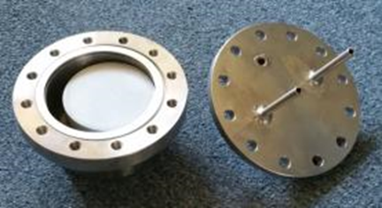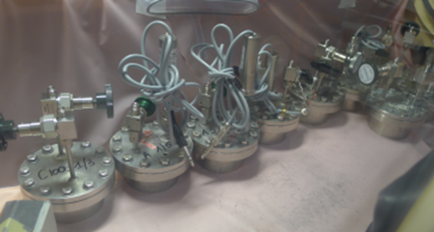

Figure 1. Stainless steel container (200 mL) with its coper gasket and its mortar sample before sealing (left picture). Closed reactors during maturation (right picture).

Table 5. Composition and activity (as of October 1st, 2015) of mixed U/Pu oxide powder used for alpha radiolysis experiments.

|  |  |  |  |  |  |  |  |  |
| --- | --- | --- | --- | --- | --- | --- | --- | --- |
| Mass % U | Mass % Pu | Total alpha activity (GBq/g) | 238Pu activity (GBq/g) | 239Pu activity (GBq/g) | 240Pu activity (GBq/g) | 241Pu alpha activity (GBq/g) | 242Pu activity (GBq/g) | 241Am activity (GBq/g) |
| 63.24 | 24.18 | 5.49 | 4.02 | 0.31 | 0.54 | 0.0015 | 0.0027 | 0.62 |

As the alpha action range is short (about 30 μm in cementitious materials), and plutonium embedded in the mortar, the water possibly adsorbed on the inner wall of container was not submitted to alpha irradiation but only slightly to gamma and beta radiations emitted by plutonium and americium. The corresponding dose rate was computed to be 1000 times lower than the alpha dose rate within the material. Thus, the gas production due to beta and gamma irradiation of water adsorbed on the inner wall of the stainless-steel containers or present within the samples was considered as negligible in these experiments.

1. **Results and discussion**
   1. **Gamma irradiation of MPC pastes**

In order to measure the radiolytic H2 yield of a material with water mainly chemically bound into the structure of K-struvite, a cement paste (P-1) was prepared with stoichiometric amounts of MgO (15.14 wt.%), KH2PO4 (51.09 wt.%) and H2O (33.77 wt.%) to form K-struvite (eq. 1), corresponding to MgO/KH2PO4 and H2O/MgO molar ratios equal to 1 and 5 respectively. To prevent segregation of the fresh mix, the samples were agitated until setting. XRD performed on the 1.5 y-old cement paste (Figure 8) confirmed the formation of K-struvite as the major hydration product. Small amounts of phosphorrösslerite (MgHPO4.7H2O), Mg2KH(PO4)2.15H2O and traces of unreacted MgO and newberyite (MgHPO4.3H2O) were also evidenced, as well as an unidentified species (peak at 2θ = 22.9°) which was also observed transiently during the hydration of MPC in paste or suspension [20, [32]]. The fast setting observed in our case (no retarder was used at this stage) may have limited the subsequent progress of cement hydration and prevented total formation of K-struvite. TGA (Figure 7), which confirmed the presence of K-struvite (max. mass loss between 70 and 170°C [20]), also showed the absence of Mg(OH)2 and K-dittmarite (KMgPO4,H2O). MPC paste samples P-1 irradiated up to 300 kGy had a normalized yield G(H2)/(mass fraction of water) of 2.1×10-8 mol/J (Table 6). For comparison, yields between 3×10-8 and 5×10-8 mol/J have been reported for Portland cement pastes [6]. Thus, the simple K-struvite paste prepared with no excess of water released about half less hydrogen compared to Portland cement pastes with the same water content.

Similar experiments were performed with MgO in excess (cement paste P-2 with MgO/KH2PO4 molar ratio = 5.4), but with a water content still corresponding the stoichiometric amount needed to ensure complete reaction of KH2PO4 into K-struvite. This configuration is interesting since excess of MgO is often used to design materials with improved mechanical strength and volume stability [[33]]. XRD analysis performed on the 1.5 y-old hardened material (Figure 8) showed, as expected, the presence of unreacted MgO, the precipitation of K-struvite and brucite Mg(OH)2 (5.6 wt.% according to TGA analysis). This phase assemblage was in good agreement with predictions from thermodynamic modelling [[34]]. Gamma irradiation experiments showed (Table 6) that cement paste P-2 produced almost the same amount of hydrogen (normalized with respect to the total water content) as the paste prepared without any excess of MgO.

For practical applications in the field of waste conditioning, boric acid is mandatory to delay the setting of a few hours [20]. Typical dosages correspond to a few percent with respect to the mass of cement (MgO + KH2PO4). The influence of such an addition on the radiolytic H2 release was thus evaluated. A paste (P-3) comprising 2 wt% of boric acid (with respect to the mass of cement) was irradiated up to a dose of 300 kGy (Table 6). XRD and TGA (Figure 7 and Figure 8) analyses showed that the phase assemblage of the hardened material showed almost no change in the presence of boric acid: K-struvite remained the main hydrate formed. A small but meaningful decrease of the normalized H2 yield was observed (Table 6).

The normalized H2 yields measured in this work are significantly lower than the yield of bulk water at neutral pH (0.45 molecules/100eV, or 4.66.10-8 mol/J) [[35]]), meaning that water in K-struvite produces significantly less hydrogen than free water. These yields are also slightly higher than those previously reported by Acher [10] on pure synthetized K-struvite (normalized yield equal to (1.3±0.1).10-8 mol/J), which might result from the presence of minor phases evidenced in the paste samples P-1 to P-3. Besides, the radiolytic yield obtained with paste P-1 is rather similar to that recently reported for another cement paste mainly comprising MgHPO4,3H2O (newberyite) (normalized yield of H2 equal to (2±0.2).10-8 mol/J for gamma irradiation) [[36]].

Table 6. Gamma radiolytic H2 yields of K-struvite pastes.

|  |  |  |  |
| --- | --- | --- | --- |
| Type of material | Stoichiometric cement paste (P-1) | Excess of MgO (P-2) | Stoichiometric cement paste plus H3BO3 (P-3) |
| G(H2) (mol/J) | (8.4±1.0).10-9 | (4.5±0.5).10-9 | (5.9±0.6).10-9 |
| Normalized yield:  G(H2)/(mass fraction of total water) (mol/J) | (2.1±0.25).10-8 | (1.8±0.2).10-8 | (1.5±0.2).10-8 |

* 1. **Gamma irradiation of MPC mortars containing fly ash (FA)**

*3.2.1 Influence of fly ash*

Materials used for waste immobilization are mortars rather than pastes. Mortar samples were thus prepared using siliceous sand and fly ash as a filler. The formulation parameters were defined as follows (Table 4):

* Mg/P and H2O/P molar ratios were fixed to 1 and 5 respectively to follow the stoichiometry of equation 1.
* The sand-to-cement (S/(MgO+KH2PO4)) weight ratio was set to 1. This value resulted from a compromise to get moderate temperature rise due to cement hydration, workable mortar in the fresh state, and volume stability in the hardened state.
* The fly ash-to-cement (FA/(MgO + KH2PO4)) weight ratio was also set to 1 to get a stable mortar in its fresh state. In a previous work, Le Rouzic [33] has shown indeed that, in the absence of fly ash, the water-to-cement ratio should not be higher than 0.2 to avoid segregation in the fresh state. This water content is far below the chemical water demand of the cement (corresponding to a water-to-cement weight ratio of 0.51 according to equation 1), meaning that a large part of the reagents remain unreacted, which can be deleterious for the long-term evolution of the material, with a risk of expansion and efflorescence [[37]].

The properties of the mortar are summarized in Table 15. It should be pointed out that it was possible to design a fluid mortar with a water content corresponding to the chemical water demand of the cement. Thus, the fraction of residual free water in the porosity was expected to be limited, as well as the radiolytic gas release. The hardened mortar exhibited only little efflorescence (Figure 2) as well as acceptable volume stability and mechanical strength.

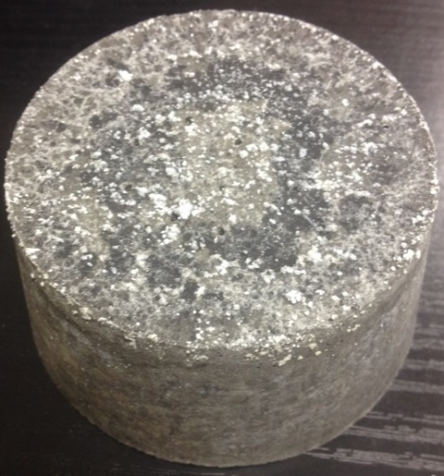

Figure 2. MPC mortar sample (10 cm by diameter) showing some efflorescence onto its free surface (formulation M-1 given in Table 4).

The mineralogy of the 2 y-old mortar was characterized by XRD (Figure 9): K-struvite was evidenced in addition to quartz (provided by the sand) and mullite (one component of the fly ash). Residual MgO was hardly detectable whereas this phase is often well detected in less mature materials. In agreement with previous work [[38], [39]], the reactivity of fly ash remained limited and possible hydration products (AlPO4.xH2O, Mg3Si2O5(OH)4, Ca6Si2O7(OH)6…) remained below the detection limit of the XRD method used.

The behaviour under gamma irradiation of the mortar designed according to formulation M-1 was investigated using four different batches of low-CaO fly ash (mortars M-1 to M-3 (Table 4). The H2 yields obtained in each case are summarized in Table 7. A significant influence of the fly ash batch was evidenced. The G(H2)/water yields were reduced by a factor 2 to 4 as compared to the reference paste sample with FA coming from Cordemais and Carling power stations, but this effect was not observed with fly ash from Hornaing. Considering the close chemical composition of the different FA used, it is difficult to explain this result. Nevertheless, it can be pointed out that the Hornaing FA showed the highest loss on ignition (due to unburnt coal residues), as well as a coarser particle size.

Table 7. Gamma radiolytic H2 yields of MPC-based mortar samples containing low calcium FA and retarded by boric acid. Airtight conditions during maturation and irradiation.

|  |  |  |
| --- | --- | --- |
| Formulation | G(H2)  (mol/J) | Normalized yield: G(H2)/(mass fraction of total water)  (mol/J) |
| Mortar M-1 (with Cordemais FA, batch 2013) | (1.05±0.1).10-9 | (5.9±0.6).10-9 |
| Mortar M-2 (with Hornaing FA, batch 2018) | (2.2±0.2).10-9 | (1.3±0.1).10-8 |
| Mortar M-3 (with Carling FA, batch 2017) | (0.65±0.1).10-9 | (3.7±0.6).10-9 |
| Stoichiometric cement paste with 2%mass. H3BO3 but no FA |  | 1.5.10-8 (reminder of Table 6) |
| Bulk water (neutral pH) [35] | 4.66.10-8 | |

Traces of O2 and N2 (< 0.5% of total gas) were always detected in the glass tubes after gamma irradiation regardless of the integrated dose. These gases likely originated from micro-leaks during tube sealing under argon or sample degassing after the sealing (sample were stored in air before sealing and thus porosity and voids may have contained some air). CO2 was also evidenced after irradiation (Figure 3), at a concentration close to 0.4% of total gas whatever the gamma dose. This concentration was too high to be explained by air leaks, and was likely due to radiolysis. The only known source of carbon in the samples of MPC mortar being fly ash (unburnt coal residues evidenced by loss on ignition at 950°C in Table 13), CO2 probably resulted from radiolysis of FA. The rather constant amount of CO2 analysed from 300 kGy to 5 MGy (Figure 3) suggested that complete production of CO2 was achieved at doses smaller than 300 kGy. This constant amount of CO2 might also be explained by sample degassing after glass tube sealing (before irradiation), provided that most of the CO2 is present within the material before irradiation. In this case, CO2 would not originate from radiolysis.

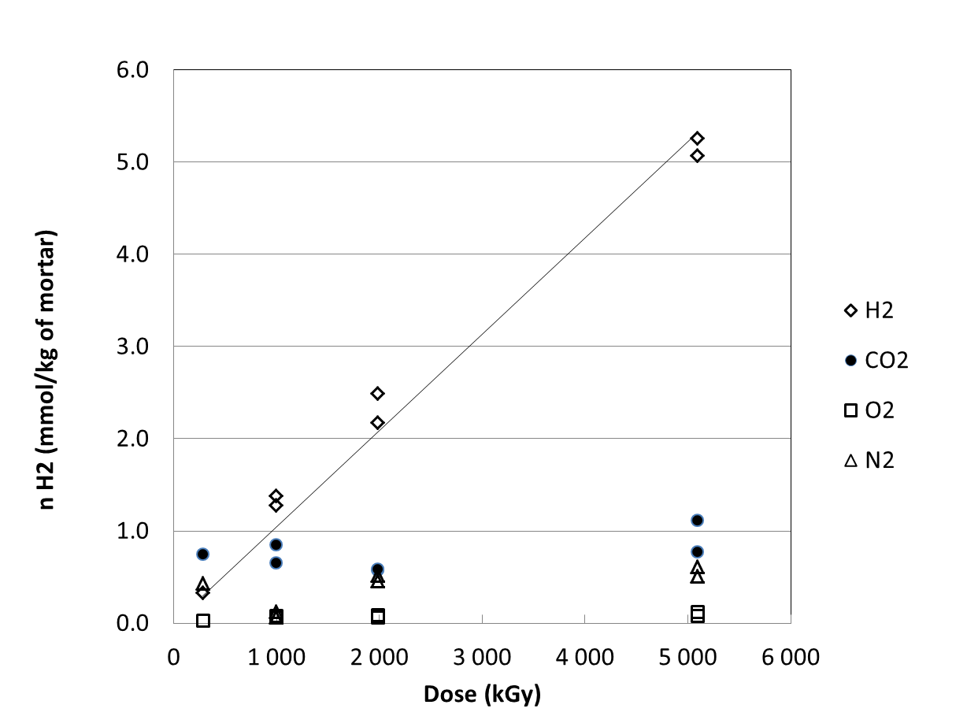

Figure 3. Production of gas as a function of the dose by 10-mL cylindrical samples of MPC mortar under gamma irradiation (mortar containing Cordemais 2013 FA).

*3.2.2 Influence of water content*

Two additional mortars were prepared with water content in default (15.2 wt% -mortar M-4 of Table 6) or in excess (19.6 wt.% - mortar M-5 of Table 6) as compared to the chemical water demand of cement based on equation 1 (17.6 wt.%). Their properties are summarized in Table 16. Reducing the amount of water at 15.2% hardly reduced the radiolytic H2 production as shown in Figure 4. Moreover, this strategy is not recommended since the hardened material exhibited important efflorescence and strong expansion (+0.57% at 90 days, as already reported in previous studies [33, 37]. Reversely, the addition of a large excess of water (considering K-struvite formation) should also be avoided in view of the increase in H2 production (Figure 4) and loss of mechanical strength (Table 16), even though it is a solution to improve workability of wasteforms prepared with dry powered waste (such as incineration ash for instance). A better strategy to increase workability in this case would rather be to decrease the fly ash content. This balance between the contents of FA and Pu-containing incinerator waste in MPC mortar has already been investigated at Argonne National Laboratory in the 1990’s [11].

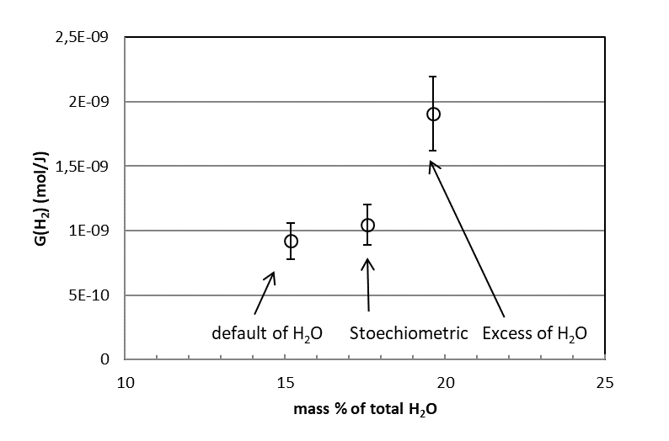

Figure 4. Influence of the water content on MPC mortars on gamma radiolytic H2 production (formulations M-1, M-4 and M-5 detailed in Table 16).

*3.2.3 Effect of high cumulative doses on mechanical strength and dimensional stability of MPC mortar*

MPC mortar samples (4x4x16 cm bars prepared with formulation M-1) were submitted to gamma irradiation up to a high cumulative dose of 10 MGy. This dose value is expected to be an upper limit for intermediate-level radioactive wasteforms after 100 years of self-irradiation. One of the most radioactive and well documented cement-waste forms has been produced in the UK from dissolution residues of spent fuel (waste stream 2F10/C referred as “Encapsulated Centrifuge Cake [[40]]). It contains about 0.63 TBq/m3 of alpha and 13 TBq/m3 of beta and gamma emitters, which leads to estimated doses deposited in the material over 100 years of 2 MGy for beta and gamma emitters (upper limit assuming that energy of the emitters is fully deposited in the wasteform, which is true for alpha and beta irradiation, but greatly overestimated for gamma irradiation) and 1 MGy for alpha emitters.

The properties of irradiated mortars M-1 were compared to control non-irradiated samples cured under the same conditions of temperature and relative humidity (Table 8). Irradiation had no significant influence on the compressive and flexural strength of the mortar, whatever the curing conditions. This result shows that MPC-based materials are as resistant to gamma irradiation as calcium silicate cement-based materials [[41], [42], [43]] or alkali-activated aluminosilicate-based materials [[44]] irradiated at similar doses. Considering now dimensional stability of 4x4x16 cm mortar bars, no notable swelling nor shrinkage was measured after irradiation, the slight evolutions (length change below 0.02%) being very similar to those of the non-irradiated control samples.

Other characterizations such as XRD analysis, thermogravimetric analysis (TGA), water porosimetry were also performed in order to detect possible modifications of the mineralogy and microstructure of the mortar due to gamma irradiation at 10 MGy. The diffraction patterns of both irradiated and non-irradiated samples were very similar (Figure 5), showing mainly the presence of quartz (from the sand) and K-struvite. Some of the diffraction peaks of K-struvite exhibited different intensities, which was likely due to preferential orientations of crystals in the samples. K-struvite is known indeed to precipitate as needles or acicular crystals in MPC-based materials with low Mg/P ratios [[45], [46]]. Mullite, one of the components of FA, and unreacted MgO were barely detectable. The thermograms of the control and irradiated samples (Figure 6) were also comparable, with one main weight loss between 80°C and 150°C, assigned to the dehydration of K-struvite. As for the total porosity accessible to water, it was not modified by the irradiation (Table 9).

Table 8. Effect of gamma irradiation on mechanical strength of 4x4x16 cm samples of MPC mortar M-1. Control samples were not irradiated but cured under the same conditions of temperature and relative humidity.

|  |  |  |
| --- | --- | --- |
|  | Compressive strength (MPa) | Flexural strength (MPa) |
| Irradiation at 10 MGy after 8 months of maturation at 100% R.H. ( | 43±4 (age: 630 d.)  41±2 (control samples) | 5.1 and 6.4  5.8 and 5.0 (control samples) |
| Irradiation at 10 MGy after 8 months of maturation at 50% R.H. | 51±4 (age: 630 d.)  50±2 (control samples) | 7.6 and 7.5  7.5 and 8.0 (control samples) |
| Irradiation at 10 MGy after 8 months of maturation in airtight bags | 42±2 (age: 630 d.)  44±6 (control samples) | 6.1 and 6.3  6.2 and 6.2 (control samples) |

Table 9. Effect of gamma irradiation on total porosity of MPC mortar M-1 samples. Control samples were not irradiated but cured under the same conditions of temperature and relative humidity.

|  |  |
| --- | --- |
|  | Porosity (%Vol.)  (Water porosimetry, samples dried at 40°C) |
| Irradiated (10 MGy), curing at 50% R.H. | 13.1±1 |
| Control sample, curing at 50% R.H. | 12.4±2 |
| Irradiated (10 MGy), curing at 100% R.H. | 10.3±1 |
| Control sample, curing at 100% R.H. | 11.0±1 |
| Irradiated (10 MGy), curing in airtight bag | 11.8±0.3 |
| Control sample, curing in airtight bag | 12.7±3 |

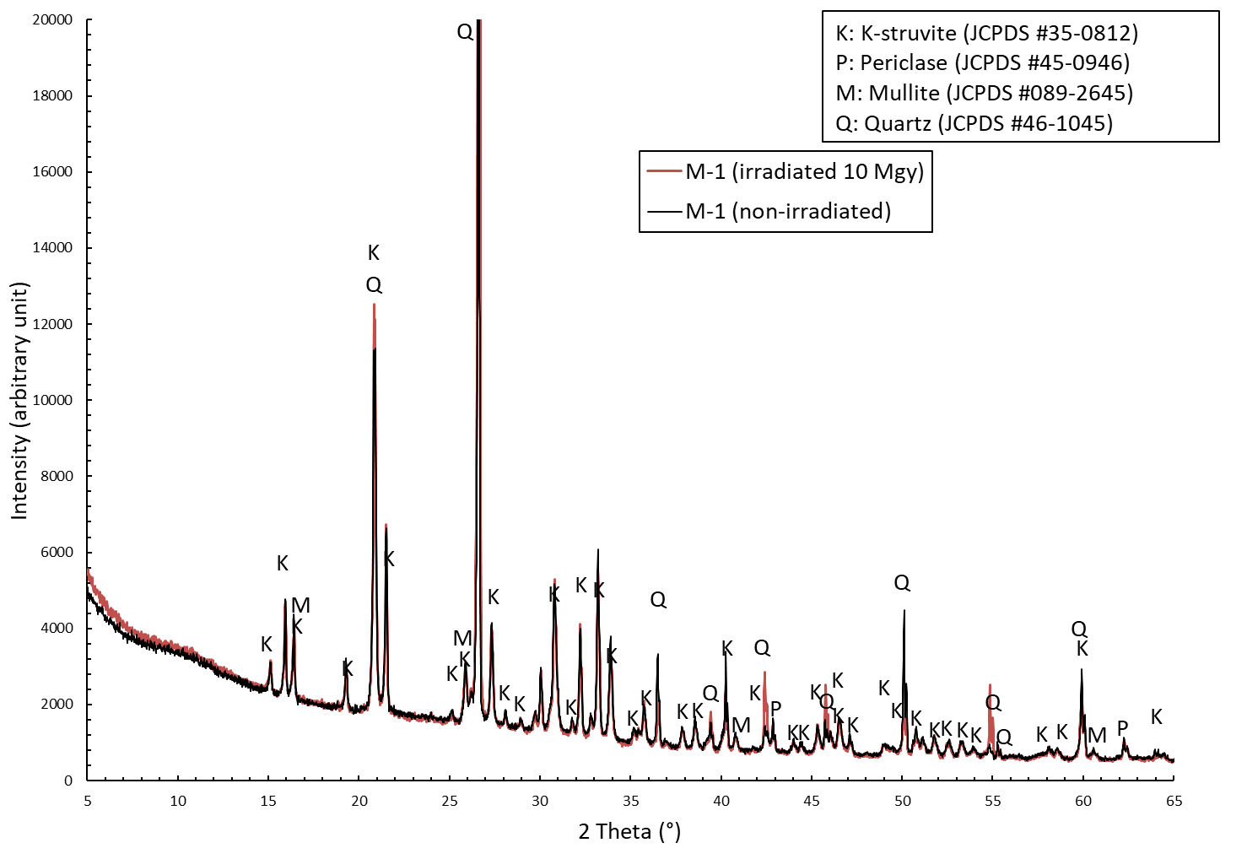

Figure 5. XRD patterns of gamma irradiated (10 MGy) and non-irradiated MPC mortars M-1. Samples stored 1 year in airtight bags prior to irradiation in sealed glass tubes. The control sample was not irradiated but cured under the same conditions of temperature and relative humidity (i.e. airtight bag).

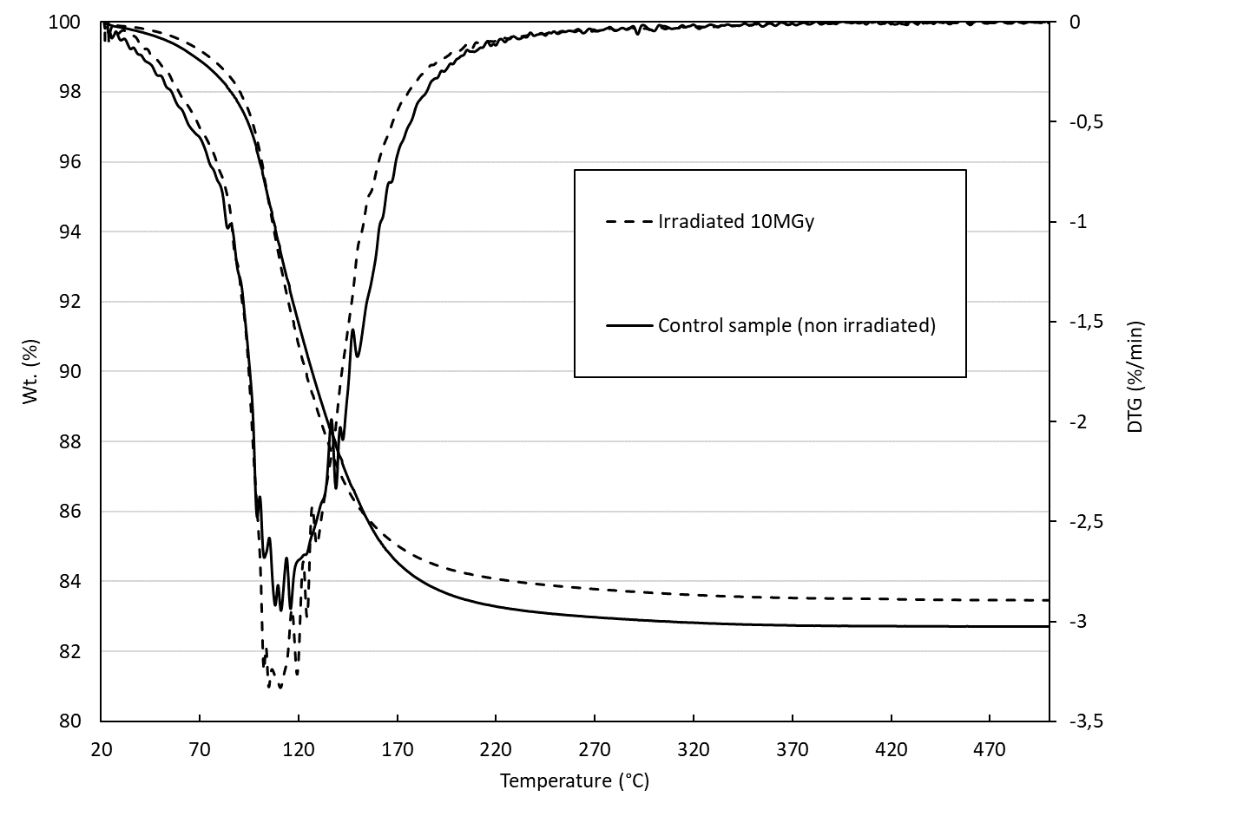

Figure 6. Thermogravimetric analysis of MPC mortar sample M-1 irradiated at 10 MGy under gamma radiation. Comparison with non-irradiated control sample.

* 1. **Alpha irradiations of MPC mortars containing fly ash (FA) through direct encapsulation of plutonium-uranium oxide**

Since intermediate-level radioactive waste can contain significant contents of alpha emitters [40], MPC mortars (formulation M-1) were also submitted to alpha auto-irradiation by dispersing a mixed uranium and plutonium oxide powder within the matrix. Gas release was measured under different conditions and compared to that of reference mortars, also containing the same amount of UO2-PuO2, but prepared with Portland cement instead of MPC. These reference materials (formulation M-8 of Table 6), which comprised a powerful superplasticizer, contained less water (10.18 wt.%) than the MPC mortar M-1 (17.58 wt.%).

Six 150 mL samples were prepared for each kind of mortar (labelled M-1-1 to M-1-6 for MPC mortar, and M-8-1 to M-8-6 for PC mortar). Each sample contained 1.5 GBq of alpha emitters, corresponding to an alpha activity close to 10 TBq/m3 of mortar. Such high value, about 16 times larger than that of the cemented “centrifuge cake” in the UK [40], was selected for two reasons: *(i)* make it possible to produce enough H2 for detection over the duration of the study (considering the mean dose rate of the samples (close to 4.5x10-3 Gy/s), the cumulated dose over one year was only 0.15 MGy), and *(ii)* consider doses possibly representative of optimized wasteforms that might be produced in the future.

The radiolytic gas productions of MPC and PC mortars are compared in Table 10. Despite a higher water content, the MPC samples released about 50% less H2 than the PC samples. Theoretical H2 yields were calculated for MPC and PC mortars assuming that all the water they contained produced H2 according to the primary yield of liquid water:

[[47]]

Only cement pastes were considered for this estimation for two reasons: *(i)* alpha emitters are embedded in the cement paste, and *(ii)* the range of alpha particle is short (about 30 to 40 μm in cementitious materials [[48]]) so that ionisation tracks are more likely to occur in the cement paste than in the sand of mortars. Moreover, considering the size of sand grains used (0.1 to 1.2 mm with d50 = 0.48 mm), the core of sand grains cannot be affected by the short range of alpha ionisation tracks. The volume of such core is equal to about 73 vol.% of the grain considering the sand grain size distribution and the range of alpha particle of 35 μm. In addition, considering the absorption of water by the quartzitic sand as negligible, the mass fractions of water of cement paste for M-1 (MPC) and M-8 (Portland) mortars are equal to 24.5wt.% and 21.7wt.% respectively. The corrective factor was introduced to take into account the difference of the alpha stopping power or Linear Energy Transfer (LET) between water and the different mineral phases present in the mortars.

$$\left(corrective factor\right)=\frac{R_{p}^{α,water}\left({\overline{E}}_{α}\right)}{R_{p}^{α,matrix}\left({\overline{E}}_{α}\right)}∙\frac{ρ_{matrix}}{ρ_{water}}$$

where $R_{p}^{α,water}\left({\overline{E}}_{α}\right)$ is the range of alpha particle with energy ${\overline{E}}_{α}$ in water and $R_{p}^{α,matrix}\left({\overline{E}}_{α}\right)$ the range of alpha particle with energy ${\overline{E}}_{α}$ in the cementitious material. ${\overline{E}}_{α}$ represents the mean energy of the alpha particle. $ρ_{matrix}$ and $ρ_{water}$ are the density of the matrix and water. A more simplified approach is also proposed considering the corrective factor as equal to 1.

The results in Table 10 show that the experimental G(H2) yield of MPC mortar was about four times smaller than the theoretical one, whereas the difference is smaller (a factor two) for PC mortars. Since water is mainly chemically bound into the structure of K-struvite in MPC mortars, this suggests that water in K-struvite produces significantly less hydrogen than free water. The same conclusion has been drawn considering gamma irradiation of MPC materials. Acher [10] measured the normalized yield of H2 for synthetic K-struvite under gamma irradiation and also observed a reduction by a factor 3 as compared to the yield of liquid water. This beneficial effect of binding water in the hydrates was not so noticeable for PC mortar. One reason may be the high normalized yield of H2 for C-S-H, the main hydrate of Portland cement, which can even exceed that of liquid water due to confinement effects under gamma irradiation [[49]]. MPC mortars may thus be interesting materials to reduce H2 production of cement wasteforms as compared to conventional PC-based materials. Nevertheless, humidification of MPC mortar M-1 in 100% R.H. gas flow increased its H2 production under alpha irradiation by about 70% compared to the production measured by accumulation in a closed reactor. On the other hand, the drying effect of the 50% R.H. argon flow, (which induced a weight loss close to 2.5% for the MPC mortar, corresponding to 4% of the water content), caused a G(H2) decrease by about 8 % as compared with non-dried samples measured in closed reactor. Such effects were not so marked for Portland mortar M-8.

Considering both MPC and PC mortars, the alpha H2 yields measured in the present work are rather consistent with previously reported data (see Table 2), except for the unique and doubtful very small value given in [13] for MPC material.

Considering radiolytic O2 production, measurements performed under argon flow did not make it possible to assess this parameter since atmospheric contamination led to O2 concentrations of about 2000 ppm in the gas sampling system despite all the experimental precautions. This value should be compared to radiolytic H2 concentrations of about 10 to 40 ppm in the argon flow of the experiments. Nevertheless, reliable results were obtained for specimens in closed reactors using the accumulation method. Accumulation over several weeks led to a significant H2 build-up (typically 0.5 to 2%), with O2/H2 ratios varying from 0.31 to 0.42 for MPC mortars. These ratios were corrected by subtracting O2 from atmospheric contamination of the sampling system (estimated to be one fourth of the N2 concentration), resulting in an O2/H2 radiolytic ratio of 0.20±0.04 for MPC mortar M-1. In the case of Portland mortar M-8, raw O2/H2 ratios ranging from 0.014 to 0.28 were measured with the accumulation method, leading to very small corrected values (<0.1). This result seems contradictory with that of Bibler [7] who reported a O2/H2 ratio of 0.35 for a Portland cement-based wasteform. The fact that this wasteform contained incineration ashes may have influenced the result. The consumption of radiolytic O2 in mortar M-8 by radio-oxidation of its organic-based superplasticizer may also be another hypothesis to explain the very low O2 release observed in this work.

Table 10. Alpha radiolytic H2 yields of MPC (M-1) and PC (M-8) mortars containing U-PuO2.

|  |  |  |  |  |  |
| --- | --- | --- | --- | --- | --- |
| Sample Ref. | Cement | Condition of measurement | G(H2) (mol/J) | Normalized yield (mol/J):  G(H2)/(mass fraction H2O) | G(O2)/G(H2) |
| M-1-1 | MPC | 50% R.H. Ar flow | (7.5±0.2).10-9 |  | Not measured because of atmospheric contamination |
| M-1-2 | MPC | 50% R.H. Ar flow | (7.7±0.4).10-9 |
| M-1-3 | MPC | Accumulation under argon | (8.8±0.9).10-9 | 5.0.10-8 | 0.16; 0.18 |
| M-1-4 | MPC | Accumulation under argon | (7.9±0.7).10-9 | 4.5.10-8 | 0.19; 0,26 |
| M1-5 | MPC | 100% R.H. Ar flow | (1.67±0.07).10-8 |  | Not measured because of atmospheric contamination |
| M-1-6 | MPC | 100% R.H. Ar flow | (1.20±0.09).10-8 |
| Theoretical yield considering primary yield of H2 and total water content (24.5 wt.%) of the cement paste of MPC mortar | | | 4.3.10-8 (with corrective factor)  3.3.10-8 (without* corrective factor) | Bulk water at pH = 7  G(H2) = 1.35.10-7 |  |
| M-8-1 | Portland | Accumulation under argon | (1.9±0.1).10-8 | 1.87.10-7 | < 0.1 |
| M-8-2 | Portland | Accumulation under argon | (1.4±0.2).10-8 | 1.40.10-7 | < 0.1 |
| M-8-3 | Portland | 100% R.H. Ar flow | (2.4±0.1).10-8 |  | Not measured because of atmospheric contamination |
| M-8-4 | Portland | 100% R.H. Ar flow | (2.3±0.1).10-8 |
| M-8-5 | Portland | 50% R.H. Ar flow | (2.13±0.07).10-8 |  | Not measured because of atmospheric contamination |
| M-8-6 | Portland | 50% R.H. Ar flow | (1.89±0.02).10-8 |
| Theoretical yield considering primary yield of H2 and total water content (22.1 wt.%) of the cement paste of PC mortar | | | 4.4.10-8 (with corrective factor)  3.4.10-8 (without* corrective factor) | Bulk water at pH = 13 [47]  G(H2) = 1.52.10-7 |  |

* i.e. corrective factor set as equal to 1.

In addition to radiolytic gas production, the influence of high alpha doses on mechanical strength and dimensional stability should also be assessed to mimic the ageing of wasteforms containing high amounts of alpha emitters. Accelerated alpha irradiation would imply embedding high contents of alpha emitters in a cement-based material to get a substantial integrated dose within a reasonable period of time. For instance, encapsulation of 100 TBq/m3 of alpha emitters (of about 5.3 MeV) would produce a dose of about 1.5 MGy in one year in the cement matrix. However, accelerating the dose rate in this way can lead to cracks due to over-pressurization within the pore network of the matrix because of the radiolytic gas build-up [3, 4, 5]. This is especially a main concern when the cementitious material is placed in a wet environment: the pore network is then (almost) fully saturated, which enhances the radiolytic gas production and, at the same time, slows down gas evacuation by diffusion. Thus, cracks observed at high dose rate may not be representative of the long-term evolution of wasteforms with a smaller and more realistic activity. This kind of experiment has yet been performed with a binder comprising 10 % Portland cement and 90% blast furnace slag (BFS) [15]. The high alpha activity (4320 TBq.m-3 of wasteform) made it possible to reach a dose of 32 MGy in 190 days for the most active specimen. Its compressive strength decreased by a factor 5 when the dose increased up to 20 MGy, and then levelled off. However, the reason for this strength weakening remains unclear since a strong desiccation of the sample, evidenced by a density drop [15], also occurred during the experiment and possibly contributed to damage the material. Another study considering Portland cement blended with BFS and FA and a less important alpha activity (656 TBq.m-3 i.e. 0.33 Gy.h-1) [3] has not evidenced such a deleterious effect on mechanical strength for an integrate dose of 15 MGy. These results would suggest to limit the alpha activity to a few hundreds of TBq/m3 to investigate the influence of alpha irradiation on the mechanical strength of cement-based materials. To the best of our knowledge, this kind of experiment has not yet been performed with MPC mortars and should be the subsequent stage to be carried out to assess the potential of this new binder for the conditioning of waste with a high alpha activity.

1. **Strategies to decrease the radiolytic gas production**

Results from section 3 have shown that the radiolytic H2 production of cement wasteforms can be decreased by substituting PC for MPC and by setting the water content to a value close to the chemical water demand of the cement (which corresponds to a water-to-cement ratio of 0.51 assuming equimolar contents of MgO and KH2PO4 and complete formation of K-struvite). The following question is then arising: is it possible to decreases further the radiolytic H2 release of MPC mortars through optimization of the mortar formulation by an addition of radical scavengers or H2 getters? Complementary experiments were thus carried out to assess these two strategies in case of external gamma irradiation. A third strategy, investigated by Wagh [12] and consisting in heating MPC materials at moderate temperature (110°C) to remove the main part of its water, is also discussed.

* 1. **Effect of radical scavengers on gas production under gamma irradiation**

It is well-known that nitrate and nitrite salts decrease the radiolytic H2 production of aqueous solutions [35]. These products, named scavengers in the field of radiolysis science, are assumed to react with radiolytic precursors of H2 such as solvated or presolvated electron. Thus, LiNO3 (2 wt.% / cement) or NaNO2 (2 wt.% /cement) were added to “stoichiometric” mortar M-1 presented in Table 6 at a dosage of 2 wt% with respect to the mass of cement (MgO + KH2PO4). LiNO3 was selected as the nitrate salt because of its beneficial effect to mitigate the corrosion of metallic aluminium [24], one of the potential wastes to be immobilized using MPC mortar. The results of gas production under gamma irradiation (Table 11) show that the decrease in the H2 production was very limited with NaNO2, but much more important with LiNO3. Nevertheless, side effects were noticed in both cases. With NaNO2, significant N2O production was evidenced. Its magnitude was comparable to the H2 production occurring in the absence of NaNO2. Likewise, adding LiNO3 caused a significant O2 production. The addition of NaNO2 or LiNO3 thus did not reduce the overall gas production. Consequently, their use in the MPC mortar formulation would not prevent possible damage due to over pressurization in the wasteforms in case of high dose rate.

Table 11. Influence of lithium nitrate or sodium nitrite on radiolytic gas production of MPC mortar.

|  |  |  |  |  |
| --- | --- | --- | --- | --- |
|  | G(H2) (mol/J x 108) | G(O2) (mol/J x 108) | G(N2O) (mol/J x 108) | G(NO) (mol/J x 108) |
| Without additive | 0.1±0.01 | Not significant* | Not detected | Not detected |
| With NaNO2 | 0.08±0.01 | Not significant* | 0.1±0.04 | 0.02±0.01 |
| With LiNO3 | 0.007±0.001 | 0.14±0.04 | Not measured | Not measured |

* of the same magnitude order than O2 from atmospheric contamination due to imperfect sealing of the glass ampoules.

* 1. **Effect of MnO2/Ag2O getter on gas production under gamma irradiation**

The trapping systems that are able to limit hydrogen release [[50]] are often classified as organic, inorganic (oxides) and hybrid getters. In this work, the focus was placed onto the MnO2/Ag2O inorganic getter for several reasons: its better resistance to irradiation as compared to organic getters, its good stability in air or under water unlike certain metal hydrides, its reasonable cost due to the replacement of noble metal (Pd, Pt…) by Ag2O as a catalyst, and its ability to irreversibly trap dihydrogen. The MnO2/Ag2O getter was first described by Kozawa *et al*. in the 1980s [[51], [52], [53]]. The allotropic form of MnO2 strongly influences the H2 trapping rate. The γ-MnO2 phase (nsutite) made from an inter-growth of ramsdellite and pyrolusite was found to be the most efficient getter towards dihydrogen [[54]].The trapping mechanism was largely debated [54, [55], [56]], but recent work by Galliez *et al*. using Fourier Transform Infra-Red (FTIR) spectroscopy and X-ray diffraction (Pair Distribution Function analysis) provided evidence of MnOOH formation in the allotropic forms of groutite ( H in 2x1 tunnels) at first, and then of manganite (H in 1x1 tunnels) [[57]]. Analysis of the silver-based phase of the getter before trapping showed the presence of small amounts of silver carbonate Ag2CO3 in addition to Ag2O due to carbonation during preparation of getter. This presence of Ag2CO3 had a positive effect since it increased the reaction rate between the getter and dihydrogen [[58]].

Some formulation parameter of the MPC mortar had to be adjusted to keep a mortar with self-levelling properties and a setting time higher than 4 h despite the addition of 10.4 wt.% getter (formulation M-6 presented in Table 6). The getter was added at the expense of FA. The dosage of this latter was thus reduced to keep the same volume fraction of (FA + getter) as that of FA in reference mortar M-1 without any getter. The amount of boric acid was doubled to counterbalance the accelerating effect of the getter on cement hydration. Observation by SEM of a polished section of the mortar after 28 d of curing in sealed bag at ambient temperature showed that the getter was rather well dispersed within the cement matrix (Figure 11). K-struvite, quartz (from the sand) and small amounts of residual MgO were evidenced by XRD (Figure 10). Note that the getter, which was poorly crystallized, could not be detected by this technique.

The MPC mortar with getter was submitted to gamma irradiation up to an integrated dose of 1 MGy. The H2 content in the headspace of the glass tube was always below the detection limit of the GC method (Table 12). However, a significant production of O2 occurred, with a yield about twice as high as that of H2 without any getter. It could result from the catalytic effect of MnO2 towards H2O2 decomposition. Indeed, H2O2 is a product of water radiolysis and MnO2 is known to decompose H2O2 into O2 and H2O at ambient temperature [[59]]:

2 H2O ⟿ H2 + H2O2 (primary radiolysis of water, other radicals or molecules are also produced)

H2O2 → H2O + 1/2 O2 (catalysed by MnO2)

To check this hypothesis, an additional mortar was produced with -MnO2 instead of the -MnO2/Ag2O getter (formulation M-7 presented in Table 6). Note that without any catalyst, -MnO2 is not an efficient getter of H2. Under gamma irradiation, this mortar produced hydrogen as expected, with a yield close to that of reference MPC mortar M-1, but also oxygen (Table 12). This oxygen production thus seemed to be due to the presence of MnO2 within the material.

To conclude, the γ-MnO2/Ag2O getter was very efficient to decrease the H2 release by MPC mortar under gamma irradiation, but it did not suppress the risk of pressure build-up in the wasteform due to strong production of O2 (about twice that of H2 without any getter). Further investigation is needed to confirm this result under alpha irradiation (Pu), and to determine whether mitigation of H2 production is still observed at high cumulative gamma and alpha doses.

Table 12. Influence of the addition of γ-MnO2/Ag2O getter and γ-MnO2 onlyon the gamma yields of gas production. Irradiations from 150 to 1000 kGy at 900 Gy.h-1.

|  |  |
| --- | --- |
| Reference MPC mortar M-1 without H2 getter (reminder of Table 15) | G(H2) = (1.05±0.1).10-9 mol/J  (G(H2)/(mass fraction of total water) = 6.10-9 mol/J)  G(O2): no significant production of O2 |
| MPC mortar M-6 with γ-MnO2/Ag2O getter | G(H2): no measurable production of H2  G(O2) = (2.0±0.1).10-9 mol/J |
| MPC mortar M-7 with γ-MnO2 only | G(H2) = (1.4±0.2).10-9 mol/J  (G(H2)/(mass fraction of total water) = 8.410-9 mol/J)  G(O2): (2.1±0.2).10-9 mol/J |

* 1. **Heating MPC materials to cause dehydration of K-struvite**

Another way to reduce drastically radiolytic H2 production of cement wasteforms is to heat them at moderate temperature to remove a significant part of water (free water and possibly weakly-bonded water in the hydrates). This strategy has been tested for Portland cement-based materials heated at 200°C [7] or 250°C [[60]] with interesting results considering alpha radiolysis (reduction of the H2 production by a factor 2000), but with a drawback of reversibility if the wasteforms are not protected from later humidification [7]. Considering MPC materials, Wagh [12] has shown that a mild drying at 110°C of a wasteform containing alpha emitters makes it possible to reduce the H2 production by a factor 9. Nevertheless, no characterisation of the material after drying is presented in his work. Considering this lack of data, 1 y-old MPC mortar M-1 was dried at 120°C for 24 h. The total transformation of K-struvite into K-dittmarite (KMgPO4,H2O) was evidenced both by XRD (Figure 12) and gravimetric measurement. The weight loss reached 15%, which corresponded to the amount of mixing water in formulation M-1, and to 5/6 of the total water content of mortar M1 (water being also provided by KH2PO4). The strongly reduced water content could thus explain the drop in the H2 production observed by Wagh. Besides, it is interesting to note that, after drying, mortar M1 kept a residual compressive strength of about 20 MPa and showed a drying shrinkage of 1600 μm.m-1, but without any cracking of the 4x4x16 cm test specimens. The low temperature required to achieve significant drying of MPC material is an advantage to reduce H2 production compared to other cements but the possible reversibility of such dehydration in moist atmosphere should be assessed in the future to define suitable storage conditions making it possible to keep a low H2 production. Further dehydration of K-dittmarite would require temperatures higher than 200°C [[61]] and would notably decrease the quality of the final product (drying shrinkage of about 2200 μm.m-1 and residual compressive strength of 13 MPa were measured for mortar M-1 heated at 300°C for 24 h).

1. **Conclusion**

Compared to Portland cement-based materials, MPC materials display lower intrinsic gamma and alpha radiolytic gas release. Their H2 radiolytic yields are reduced by a factor 2 to 3, provided that the main part of the mixing water is consumed by K-struvite formation. A moderate drying at room temperature can slightly reduce their alpha radiolytic H2 release by removing excess and unreacted water still present in the porosity whereas humidification in water-saturated atmosphere increases the alpha H2 release by about 70%. MPC mortar also release O2 under alpha irradiation with a O2/H2 ratio estimated to be close to 0.2 for mortar samples stored in closed reactors (with no drying nor humidification). However, this O2 production does not seem to occur under gamma irradiation. Furthermore, MPC mortars exhibit a good resistance towards high doses of gamma radiation (up to 10 MGy of 60Co radiation), with no decrease in the compressive and flexural strengths, no significant dimensional variation and no noticeable change in the porosity and mineralogy as compared to non-irradiated materials cured under the same conditions of temperature and relative humidity. MPC materials are thus potential candidates for the conditioning of high amounts of radioactivity with limited H2 release. Nevertheless, the resistance of MPC materials toward high doses of alpha radiation (typically several MGy) still needs to be assessed with moderate acceleration of dose rate by actinide addition to avoid non-representative effects that are suspected in previous work performed at very high alpha dose rate (about 2 Gy/s, corresponding to an incorporated activity of 4300 TBq.m-3 of wasteform).

To reduce further the radiolytic H2 release of MPC materials, the influence of radical scavengers (nitrate and nitrite) or hydrogen getter (-MnO2/Ag2O) added to the matrix has been investigated under gamma irradiation. Nitrate makes it possible to reduce drastically H2 production under gamma irradiation with the drawback of noticeable O2 production, which is comparable to the production of H2 without nitrate. Nitrite is not as efficient as nitrate to reduce H2 production. Moreover, it leads to important N2O release, so that the global amount of radiolytic gas remains unchanged or slightly higher than the H2 release without any scavenger. The effect of the hydrogen absorber is outstanding since the H2 production remains below the detection limit of the GC method used after accelerated gamma irradiation with doses as high as 1 MGy and a dose rate of 2 kGy.h-1. Nevertheless, this suppression of H2 production comes along with O2 production, which is once again slightly higher than the production of H2 measured without any getter. The concern of gas pressure build-up and cracking of materials containing high amounts of radioactivity thus still remains, even if the H2 production is strongly decreased. To complete this work, the influence of the scavengers and H2 absorber should also be studied under alpha irradiation. Moreover, their ability to mitigate or suppress H2 release still needs to be demonstrated for doses representative of temporary storage of intermediate-level radioactive wasteforms before their final disposal. The strategy consisting in heating MPC materials at moderate temperature (110°C) to remove a great part of its water has already been evaluated in the past and results in a reduction of the H2 production by almost a factor 10 under alpha radiation. The transformation of K-struvite into K-dittmarite in such conditions has been evidenced in the present work, as well as its deleterious effects on the mechanical strength and volume change of MPC materials. Besides, this strategy to dry the material to reduce its H2 production might be questionable in the long term since later humidification of the material during storage cannot be excluded. This issue should be addressed in a future work.

**Acknowledgments**

This work was supported by Andra as part of the program “Investissements d’Avenir” launched by the French government (MATRICE and MACH3 projects).

The authors are grateful to V. Labed, M. Charlot, K. Ressaire, L.Berthillot, S. Lutzler, L. Karafotis for their contribution to gamma and alpha irradiations and to A. Gerenton for his contribution to porosimetry measurements.

**Data availability**

The raw/processed data required to reproduce these findings cannot be shared at this time as the data also forms part of an ongoing study

**Appendix**

**A.1 Raw materials data**

Table 13. Chemical and physical analysis of FA used to prepare MPC mortars.

|  |  |  |  |
| --- | --- | --- | --- |
|  | FA Cordemais 2013 (wt.%) | FA Carling 2017 (wt.%) | FA Hornaing 2018 (wt.%) |
| SiO2 | 52.9 | 57.69 | 52-55 |
| Al2O3 | 21.84 | 21.75 | 20-25 |
| Fe2O3 | 10.55 | 7.1 | 8.5 |
| CaO | 3.79 | 3.82 | 1-6 |
| MgO | 1.55 | 2.29 | 3 |
| TiO2 | 0.97 | 0.92 | 1 |
| MnO | 0.09 | 0.1 | 0.5 |
| P2O5 | 0.15 | 0.48 | 0.25 |
| Cr2O3 | 0.01 |  |  |
| SrO | 0.13 | 0.12 |  |
| Na2O | 1.24 | 0.89 | 0.6 |
| K2O | 1.77 | 2.54 | 0.8-4 |
| SO3 | 0.58 | 0.58 | 0.3 à 2 |
| Cl- | 0 | 0 | 0.04 |
| S2- | < 0.01 | 0 | 0 |
| Loss on ignition at 950°C | 2.4 | 2.3 | 6.8 |
| Specific surface area (nitrogen BET) (m2.g-1) | 1.5 | 1.3 | 2.7 |
| Particle size (laser granulometry)  (volumetric distribution) | d10: 7 µm  d50: 31 µm  d90: 163 µm | d10: 5 µm  d50: 20 µm  d90: 134 µm | d10: 7 µm  d50: 39µm  d90: 147 µm |
| Phase assemblage (XRD) | Amorphous +  mullite + quartz | Amorphous +  mullite + quartz + Fe2O3 | Amorphous +  mullite + quartz |

Table 14. Oxide and phase composition of the investigated Portland cement (SR0 CEM I 52,5N PM) (data from supplier, mineralogical quantification by XRD and Rietveld refinement).

|  |  |  |  |  |  |
| --- | --- | --- | --- | --- | --- |
| Elemental composition of clinker (wt.%) | C3S (wt.% clinker) | C2S (wt.% clinker) | C3A (wt.% clinker) | C4AF (wt.% clinker) | Addition of gypsum or limestone |
| SiO2: 20.91; Al2O3: 3.51; Fe2O3: 6.51; TiO2: 0.20; MnO: 0.06; CaO: 64.91; MgO: 0.81; SO3: 1.52; K2O: 0.57; Na2O: 0,09; P2O5: 0.20; S2-:0 ; Cl-: 0.03 | 59 | 22 | 0 | 17 | 0 |

**A.2 Cement pastes data**

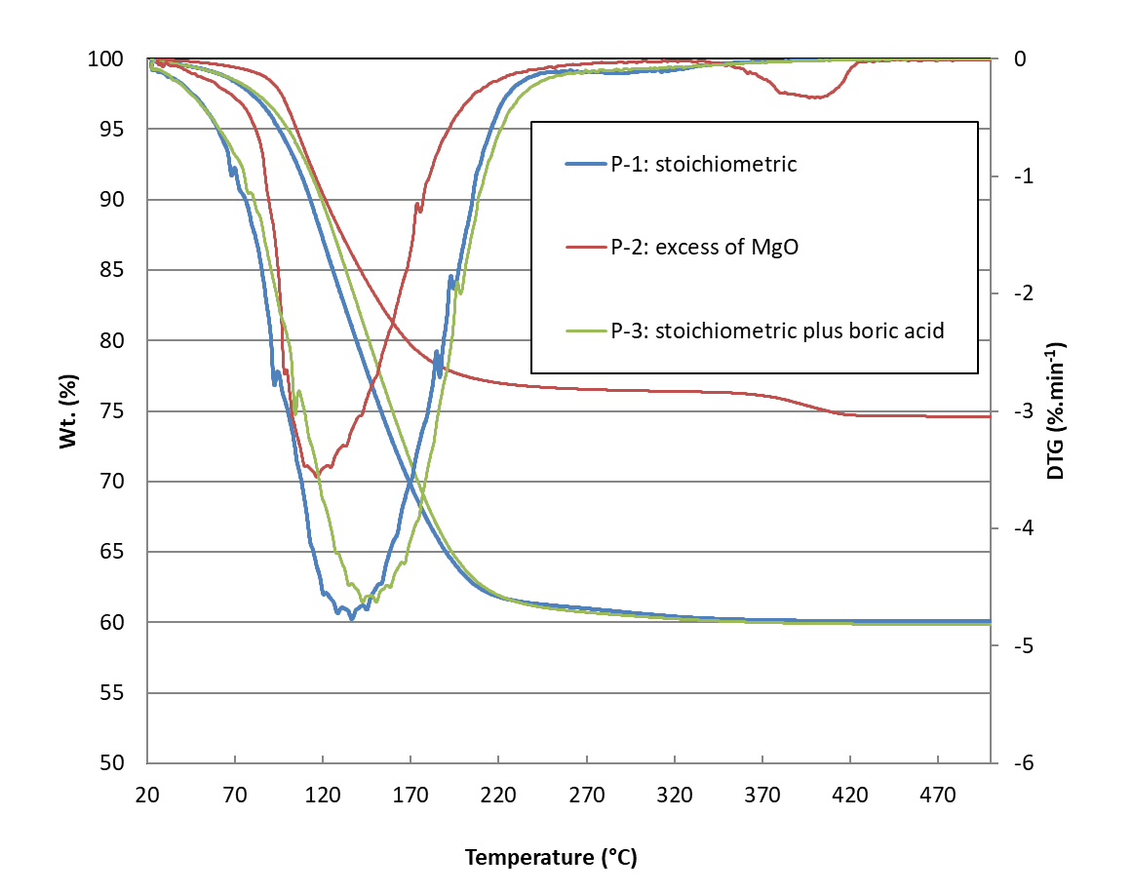

Figure 7. Thermogravimetric analysis of 1.5 y-old MPC pastes P-1, P-2 and P-3.

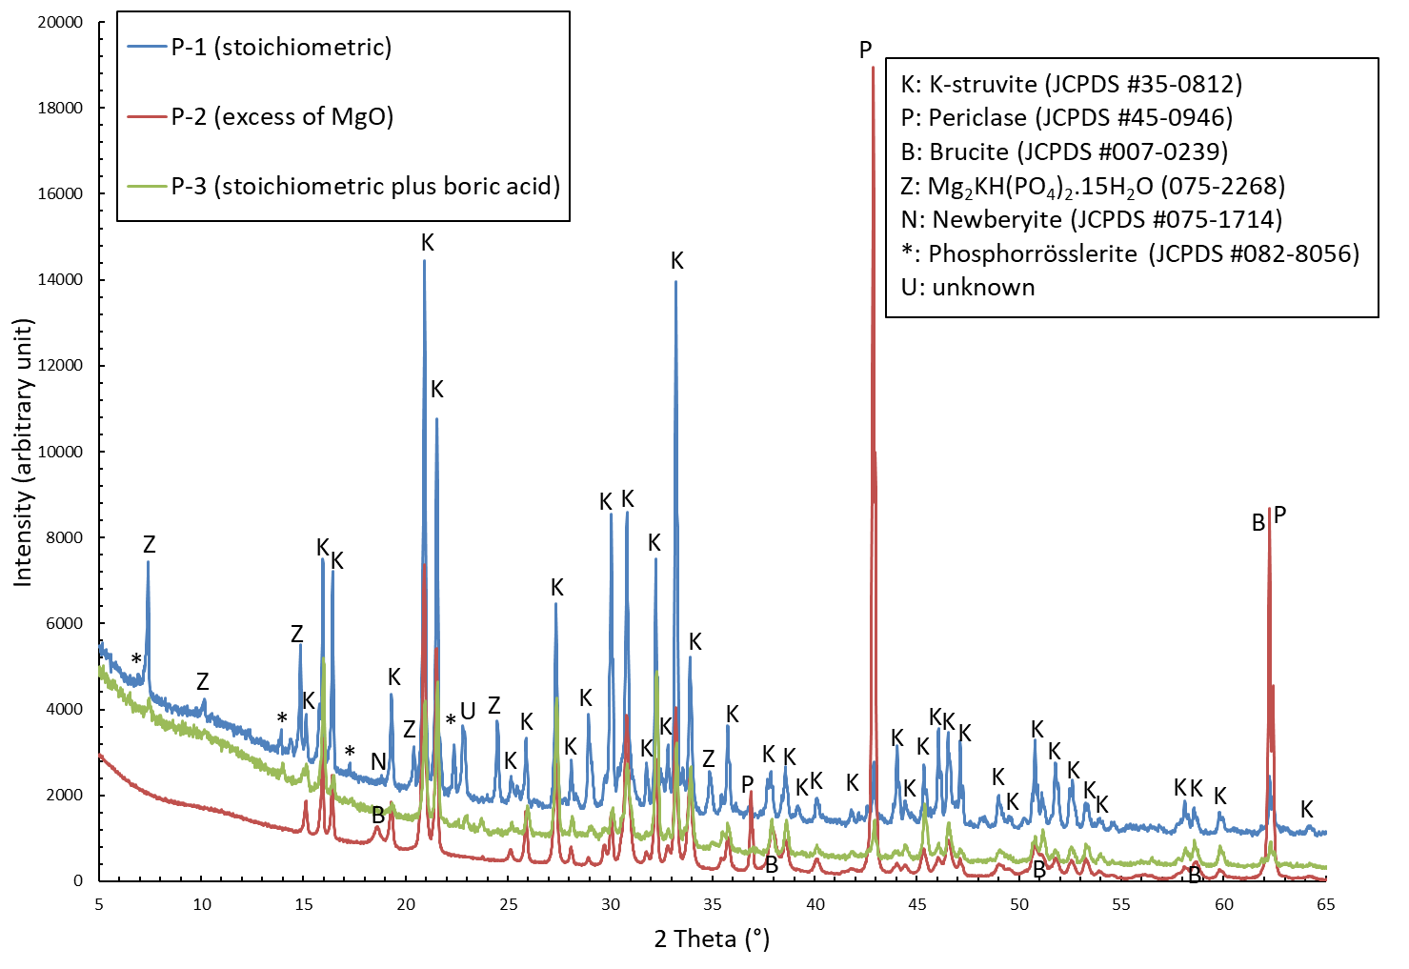

Figure 8 : XRD patterns of MPC pastes P-1, P-2 and P3 after 1.5 year of curing in sealed bag at room temperature

**A.3 Mortar data**

Table 15. Properties of the mortar M-1 containing FA from Cordemais power station (batch 2013).

|  |  |
| --- | --- |
| Rheology of freshly prepared mortar | Marsh cone flow duration for 1L (12.5 mm nozzle): 65 s  Mini ASTM cone spread diameter: 23 cm |
| Setting time (Vicat needle) | 2 h (beginning), 4 h (end) |
| Langavant calorimetry | maximum temperature rise = 42°C  Hydration heat: 520±50 J/g of MgO+KH2PO4 |
| Length change at ambient temperature of 4x4x16 cm specimens | -70 µm/m at 90 d (curing in airtight bag)  +20 µm/m at 90 d (curing under water)  -1100 µm/m at 90 d (curing in air at 50% R.H.) |
| Mechanical strength at 90 d of 4x4x16 cm specimens | Compressive: 35.8 MPa. Flexural: 5.7MPa (curing in airtight bag)  Compressive: 28.6 MPa. Flexural: 3.8MPa (curing under water)  Compressive: 46.8 MPa. Flexural: 7.1MPa (curing in air at 50% R.H.) |

Table 16. Formulation and properties of MPC mortars with various water contents (FA Cordemais batch 2013 used).

|  |  |  |  |
| --- | --- | --- | --- |
| Reference | Mortar with default of water (M-4) | Mortar with near stoichiometric amount of water (M-1) | Mortar with Excess of water (M-5) |
| Crystalline phases (detected by XRD) | quartz (sand), K-struvite, Mullite (already present in FA), Periclase (unreacted MgO). After 6 months of curing in airtight bag | quartz (sand), K-struvite, Mullite (already present in FA) | quartz (sand), K-struvite, Mullite (already present in FA), trace of Periclase (unreacted MgO). After 6 months of curing in airtight bag |
| Length change at ambient temperature of 4x4x16 cm specimens | + 2200 µm/m at 90 d. (curing in airtight bag)  + 5700 µm/m at 90 d. (curing under water)  - 600 µm/m at 90 d. (curing in at air 50% R.H.) | -70 µm/m at 90 d. (curing in airtight bag)  +20 µm/m at 90 d. (curing under water)  -1100 µm/m at 90 d. (curing in at air 50% R.H.) | -20 µm/m at 90 d. (curing in airtight bag)  + 10 µm/m at 90 d. (curing under water)  - 1200 µm/m at 90 d. (curing in at air 50% R.H.) |
| Mechanical strength at 90 d on 4x4x16 cm specimens | Compressive: 45.5 MPa. Flexural: 6.8 MPa (curing in airtight bag)  Compressive: 30.3 MPa. Flexural: 3.9 MPa (curing under water)  Compressive: 61.7 MPa. 7.5 Flexural: MPa (curing in air at 50% R.H.) | Compressive: 35.8 MPa. Flexural: 5.7MPa (curing in airtight bag)  Compressive: 28.6 MPa. Flexural: 3.8MPa (curing under water)  Compressive: 46.8 MPa. Flexural: 7.1MPa (curing in air at 50% R.H.) | Compressive: 18.5 MPa. Flexural: 3.0 MPa (curing in airtight bag)  Compressive: 15.3 MPa. Flexural: 2.3 MPa (curing under water)  Compressive: 30.0 MPa. Flexural: 5.3 MPa (curing in air at 50% R.H.) |

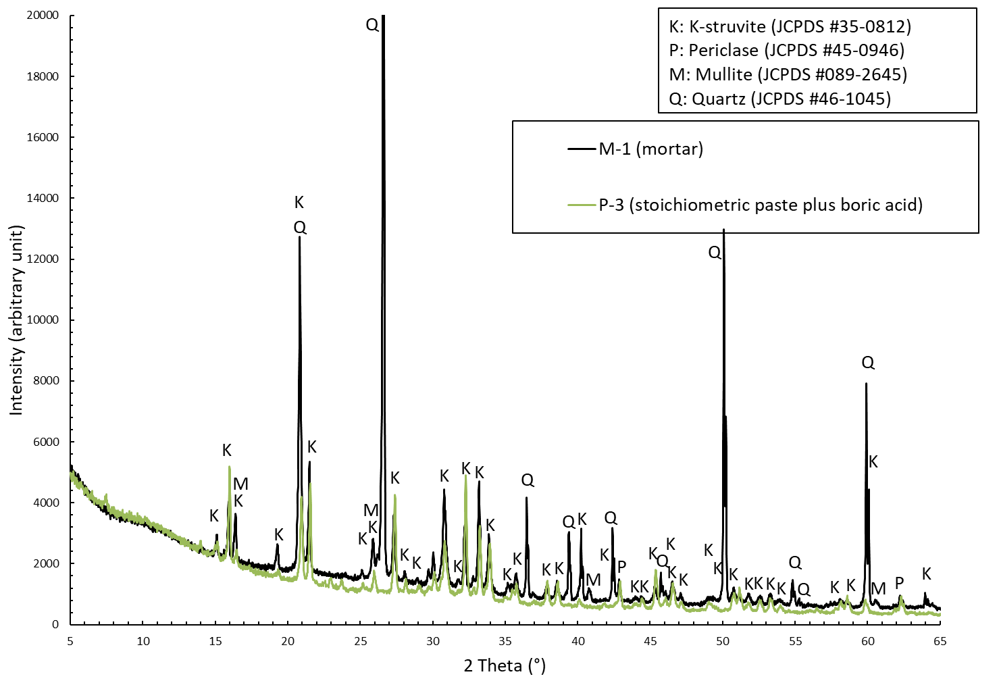

Figure 9. XRD pattern of MPC mortar M-1(and reference paste P-3) after 2 years of curing in sealed bag at room temperature



Figure 10 : XRD pattern of MPC mortar M-6 with getter after 28 d of curing in sealed bag at room temperature.

|  |  |
| --- | --- |
|  |  |

Figure 11. SEM observation of a polished section of MPC mortar M-6 with getter after 28 d of curing in sealed bag at ambient temperature. Left: BSE image – Right: Elemental mapping of Mn, P, Mg and Si –getter: pink colour, FA: light yellow, sand: bright yellow, cement paste: dark blue, residual MgO: light blue.

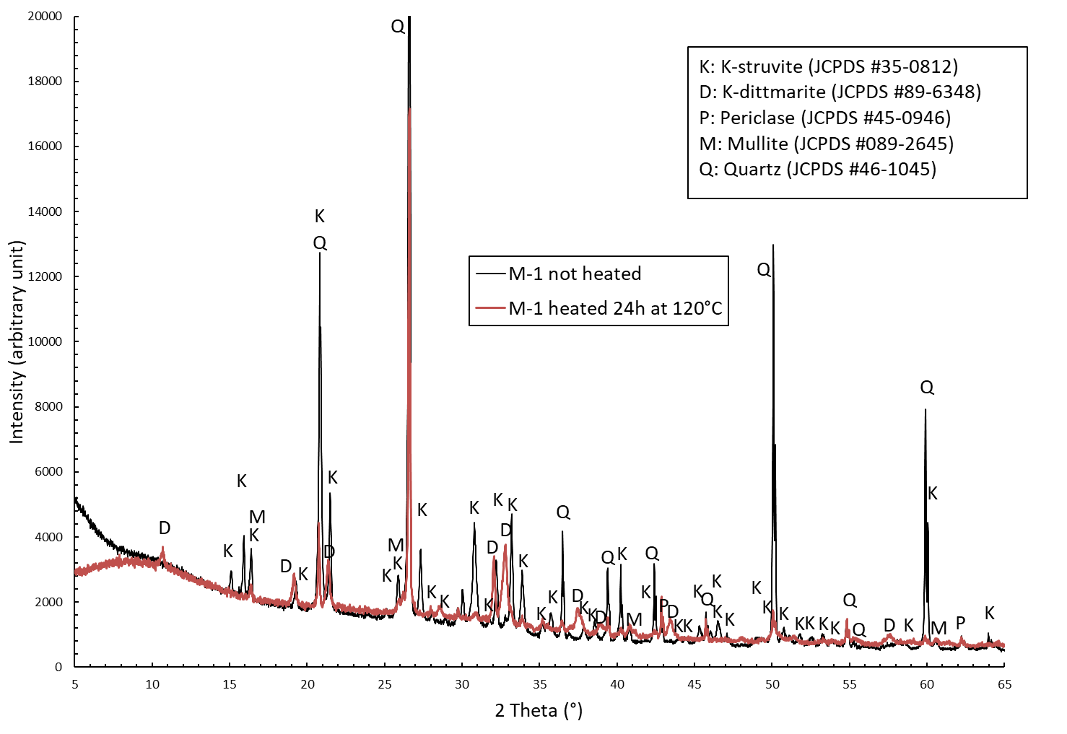

Figure 12. XRD pattern of MPC mortar M-1 before and after drying for 24 h at 120°C (sample previously stored 1 year in airtight bag before thermal treatment).

**References**

1. [] IAEA, Retrieval and Conditioning of Solid Radioactive Waste from Old Facilities, (2007). TECHNICAL REPORTS SERIES No. 456.
2. [] N.E. Bibler, Radiolytic Gas Production from Concrete Containing Savannah River Plant Waste, Savannah River Laboratory, (1978) Report DP-1464.
3. [] C. J. Kertesz, P. R. Chenavas, L. Auffret, Conditionnement de cendres d'incinérateur alpha et bêta gamma, obtenues par incinération des déchets radioactifs, par enrobage dans différentes matrices, Report EUR 14365 FR (1993) Commission européenne, Sciences et techniques nucléaires
4. [] C. Madic, G. Koehly, Comportement à long termes des matrices d’enrobage contaminées en émetteurs alpha ; Etude du phénomène de rupture d’éprouvettes constituées de liants hydrauliques contaminés en plutonium 238 et curium 244 au cours de leur lixiviation C.E.A. report, DGR, vol. 134, (1986).
5. [] C. R. Wilding, The effects of radiation on intermediatelevel waste forms – Final Report, (1988), HARWELL report AERE R 13809.
6. [] D. Chartier, J. Sanchez-Canet, L. Bessette, S. Esnouf, J.-P. Renault, Influence of formulation parameters of cement based materials towards gas production under gamma irradiation, Journal of Nuclear Materials 511 (2018) 183-190.
7. [] N. E. Bibler, Radiolytic Gas generation in concrete made with incinerator ash containing transuranium nuclides, in Scientific Basis for Nuclear Waste Management 2 (1980) 585-592.
8. [] P. Vejmelka, G. Rudolph, W. Kluger, R. Köster, Conditioning of radioactiye waste solutions by cementation, Kernforschungszentrum Karlsruhe, rapport ref. KfK 4800f (1992).
9. [] H. MOCKEL, R. KOSTER, Gas formation during the gamma radiolysis of cemented low and intermediate level waste products», radioactive waste management (1982).
10. [] L. Acher, Etude du comportement sous irradiation gamma et électronique de matrices cimentaires et de leurs hydrates constitutifs, PhD thesis, University Paris-Saclay (2017).
11. [] D.B. Barber, Gas generation in magnesium -phosphate cement solids incorporating plutonium-containing ash residue, Proceedings of the International Conference on Decommissioning and Decontamination and on Nuclear And Hazardous Waste Management, Volume 1, September 13-18, (1998), Denver, Colorado.
12. [] A.S. Wagh et al. Stabilization of Rocky Flats Pu-contaminated ash within chemically bonded phosphate ceramics, Journal of Nuclear Materials 265 (1999) 295-307.
13. [] S.E. Vinokurov et al. Low-temperature immobilization of actinides and other components of high-level waste in magnesium potassium phosphate matrices. Journal of Nuclear Materials 385 (2009) 189–192.
14. [] P. Bouniol, Original behaviour of pore water radiolysis in cement-based materials containing sulphide: Coupling between experiments and simulations, Radiation Physics and Chemistry 150 (2018) 172–181.
15. [] D.C. Phillips, The effects of radiation on intermediate level waste forms, 1987 Annual Report, HARWELL report AERE R 13019 (1988).
16. [] E. Weill, J. Bardic, Magnesium phosphate cement systems, US Patent n° 4 756 762 (1988).
17. [] I. Older, Special Inorganic Cements, Modern Concrete Technology Series. Taylor & Francis, London (2000), pp. 216-224
18. [] E. Soudée, J. Pera, Mechanism of setting reaction in magnesia-phosphate cements, Cem. Concr. Res., 30 (2000), pp. 315-321
19. [] A.S. Wagh, Chemically Bonded Phosphate Ceramics, Elsevier, Amsterdam (2004), pp. 264-267
20. [] H. Lahalle, C. Cau Dit Coumes, C. Mercier, D. Lambertin, C. Cannes, S. Delpech, S. Gauffinet, Influence of the w/c ratio on the hydration process of a magnesium phosphate cement and on its retardation by boric acid, Cem. Concr. Res. 109 (2018) 159-174.
21. [] D. Singh, A.S. Wagh, M. Tlustochowicz, S.Y. Jeong, Phosphate ceramic process for macroencapsulation and stabilization of low-level debris wastes, Waste Management (18), Issue 2 (1998), 135-143.
22. [] S.E. Vinokurov, S.A. Kulikova and B.F. Myasoedov. Magnesium Potassium Phosphate Compound for Immobilization of Radioactive Waste Containing Actinide and Rare Earth Elements, Materials, 11, 976 (2018).
23. [] S.A. Kulikova, K.Yu. Belova, E.A. Tyupina, S.E. Vinokurov, Conditioning of Spent Electrolyte Surrogate LiCl-KCl-CsCl Using Magnesium Potassium Phosphate Compound. Energies, 13, 1963 (2020).
24. [] C. Cau Dit Coumes, D. Lambertin, H. Lahalle, P. Antonucci, C. Cannes, S. Delpech, Selection of a mineral binder with potentialities for the stabilization / solidification of aluminum metal, Journal of Nuclear Materials 453 (2014) 31-40.
25. [] C. Chlique, Effect of gamma irradiation on MnO2/Ag2O hydrogen getter, Journal of Nuclear Materials, 458, (2015) 162-167.
26. [] D. Lambertin, Material for the trapping of hydrogen, process for the preparation and uses, patent FR2939700A1 (2008).
27. [] K. Galliez, P. Deniard, P.-E. Petit, D. Lambertin, F. Bart, S. Jobic, J. Appl. Crystallogr., 47 (2014), pp. 552-560
28. [] http://www.harwell-dosimeters.co.uk/perspex/
29. [] ISO-ASTM 51261 Guide for selection and calibration of dosimetry systems for radiation processing.
30. [] J. Baro, J. Sempau, J.M. Fernandez-Varea, and F. Salvat, Nuclear Instruments and Methods in Physics, Research, Sect. B 100;31 (1995).
31. [] M. Ferry, A. Dannoux-Papin, N. Dély, S. Legand, D. Durand, J.L. Roujou, C. Lamouroux, V. Dauvois, P. Coignet, F. Cochin, S. Esnouf, Chemical composition effects of methylene containing polymers on gas emission under gamma-irradiation, Nuclear Instruments and Methods in Physics Research B 334 (2014) 69–76.
32. [] H. Lahalle, C. Cau Dit Coumes, A. Mesbah, D. Lambertin, C. Cannes, S. Delpech, S. Gauffinet, Investigation of magnesium phosphate cement hydration in diluted suspension and its retardation by boric acid, Cem. Concr. Res. 87 (2016) 77-86.
33. [] M. Le Rouzic, Étude des propriétés physico-chimiques et mécaniques des matériaux cimentaires à base d’oxyde de magnésium Ph. D. Thesis Paris-Est University (2014).
34. [] B. Lothenbach, B. Xu, F. Winnefeld, Thermodynamic data for magnesium (potassium) phosphates, Applied Geochem. 111 (2019) 104450
35. [] B. Pastina, J.A. LaVerne, S.M. Pimblott, Dependence of molecular hydrogen formation in water on scavengers of the precursor to the hydrated electron, J. Phys. Chem. 103 (1999) 5841-5846.
36. [] G.L. Bykov, V.A. Ershov, B.G. Ershov, Radiolysis of the magnesium phosphate cement on gamma-irradiation, Construction and Building Materials 252 (2020).
37. [] B. Xu et al. Influence of magnesium-to-phosphate ratio and water-to-cement ratio on hydration and properties of magnesium potassium phosphate cements, Cement and Concrete Research 123, September (2019).
38. [] H. Lahalle, Conditioning metallic aluminium in magnesium phosphate cements, Ph.D. Thesis, University of Bourgogne Franche – Comté, France (2016).
39. [] B. Xu, H. Ma, H. Shao, Z. Li, B. Lothenbach, Influence of fly ash on compressive strength and micro-characteristics of magnesium potassium phosphate cement mortars, Cem. Concr. Res. 99 (2017) 86-94
40. [] UK Radioactive Waste Inventory, WASTE STREAM 2F10/C Encapsulated Centrifuge Cake, (https://ukinventory.nda.gov.uk/wp-content/uploads/2019/11/2F10_C.pdf)
41. [] A Review of the Effects of Radiation on Microstructure and Properties of Concretes Used in Nuclear Power Plants, Rapport NUREG/CR-7171 ORNL/TM-2013/263.
42. [] S. A. Kearney, C. L. Corkhill, J. L. Provis, Radiation damage effects in high volume replacement Portland cements, results presented at NUWCEM 2018, Avignon (France).
43. [] N. Mobasher, S.A. Bernal, H. Kinoshita.,C.A. Sharrad, J.L. Provis, Gamma Irradiation Resistance of an Early Age Slag-Blended Cement Matrix for Nuclear Waste Encapsulation, Journal of Materials Research, 30 (2015)
44. [] F. Chupin, Caractérisation de l’effet des irradiations sur les géopolymères, Ph.D. Thesis, University Pierre et Marie Curie (2015).
45. [] C. Chau, F. Qiao and Z. Li, Microstructure of magnesium potassium phosphate cement, Constr. Build. Mater. 25 (2011) 2911-2917.
46. [] M. Le Rouzic, T. Chaussadent, L. Stefan and M. Saillio, On the influence of Mg/P ratio on the properties and durability of magnesium potassium phosphate cement pastes, Cem. Concr. Res. 96 (2017) 27-41.
47. [] G. Auclair. Détermination des rendements radiolytiques primaires alpha en milieu alcalin. Application à la radiolyse du béton, Ph.D. Thesis, University of Paris V (2001).
48. [] J.F. Ziegler, The Stopping and Range of Ions in Solids, vol. 1 of series "Stopping and Ranges of Ions in Matter," Pergamon Press, New York (2003).
49. [] C. Yin, A. Dannoux-Papin, J. Haas, J.-P. Renault, Influence of calcium to silica ratio on H2 gas production in calcium silicate hydrate, Radiation Phys. Chem. 162 (2019) 66-71.
50. [] Nigrey, P. J., (2000). An issue paper on the use of hydrogen getters in transportation packaging. Albuquerque, SAND2000-0483, Sandia National Laboratories. SAND2000-0483
51. [] A. Kozawa, Reaction mechanism of hydrogen absorbers made of manganese dioxide, Denki Kagaku **44** (1976) 572-577.
52. [] A. Kozawa, Hydrogen Gas Absorber Made of MnO2 Catalysed with Palladium or Platinium Salts, Denki Kagaku **46** (1978) 416-418.
53. [] A. Kozawa, K.V. Kordesch, Silver-catalysed MnO2 as hydrogen absorber. Electrochimica Acta **26** (1981) 1489-1493.
54. [] K. Galliez., P. Deniard, et al. Influence of MnO2 polymorphism form on MnO2/Ag2O hydrogen getter, J. Nucl. Mater. **438** (2013) 261-267.
55. [] C. Maruéjouls, E. Bachellerie, et al. Mitigation of the hydrogen risk in fusion facilities: the first experimental results, Fusion Engin. Design **69** (2003) 585-591.
56. [] Chabre Pannetier Structural and electrochemical properties of the proton /ɣ-MnO2 system [Revue] // Progress in Solid State Chemistry. (1995). - pp. 1-130.
57. [] K. Galliez., P. Deniard, et al. Pair Distribution Function and Density Functional Theory Analyses of Hydrogen Trapping by γ-MnO2, Inorg. Chem. **54** (2015) 1194-1196.
58. [] K. Galliez, P. Deniard, et al, Modelling and quantification of intergrowth in gamma-MnO2 by laboratory pair distribution function analysis, J. Applied. Cryst. **47** (2014) 552-560.
59. [] S. P. JIANG, An Observation of Homogeneous and Heterogeneous Catalysis Processes in the Decomposition of H2O2 over MnO2 and Mn(OH)2, Journal of Catalyst 131, (1991) 88-93.
60. [] L. R. Dole et al, Cement Based Radioactive Waste Hosts Formed Under Elevated Temperatures and Pressures (FUETAP Concretes) for Savannah River Plant High-Level Defense Waste, OAK RIDGE NATIONAL LABORATORY report, ORNL/ TM-8579 (1983).
61. [] S. Zhang, H.-S. Shi, S.-W. Huang, and P. Zhang, Dehydration characteristics of struvite-K pertaining to magnesium potassium phosphate cement system in non-isothermal condition*.* Journal of Thermal Analysis and Calorimetry, **111** (2013) 35-40.